me urnciai KUDiication or alua—An international Association or security t-roressionais

April 2006

ww

Learning ^ Together

SAFETECH **r '** 2006 Review and photos I INSIDE

A Learning Institution

gets CM Locks and the U.S. Military gets biometric hand readers

PLUS!

Forrensics with Dan Cunningham, Thomas Stern takes an Interesting Call, Greg Perrg Defeats a Mosler and More!

***************Sch 3-DIGIT 303

Breck H. Camp CML PO Box 47070 Atlanta GA 30362-0070

**lull.II Illllllllllllllllllllllllllllllllll.il**

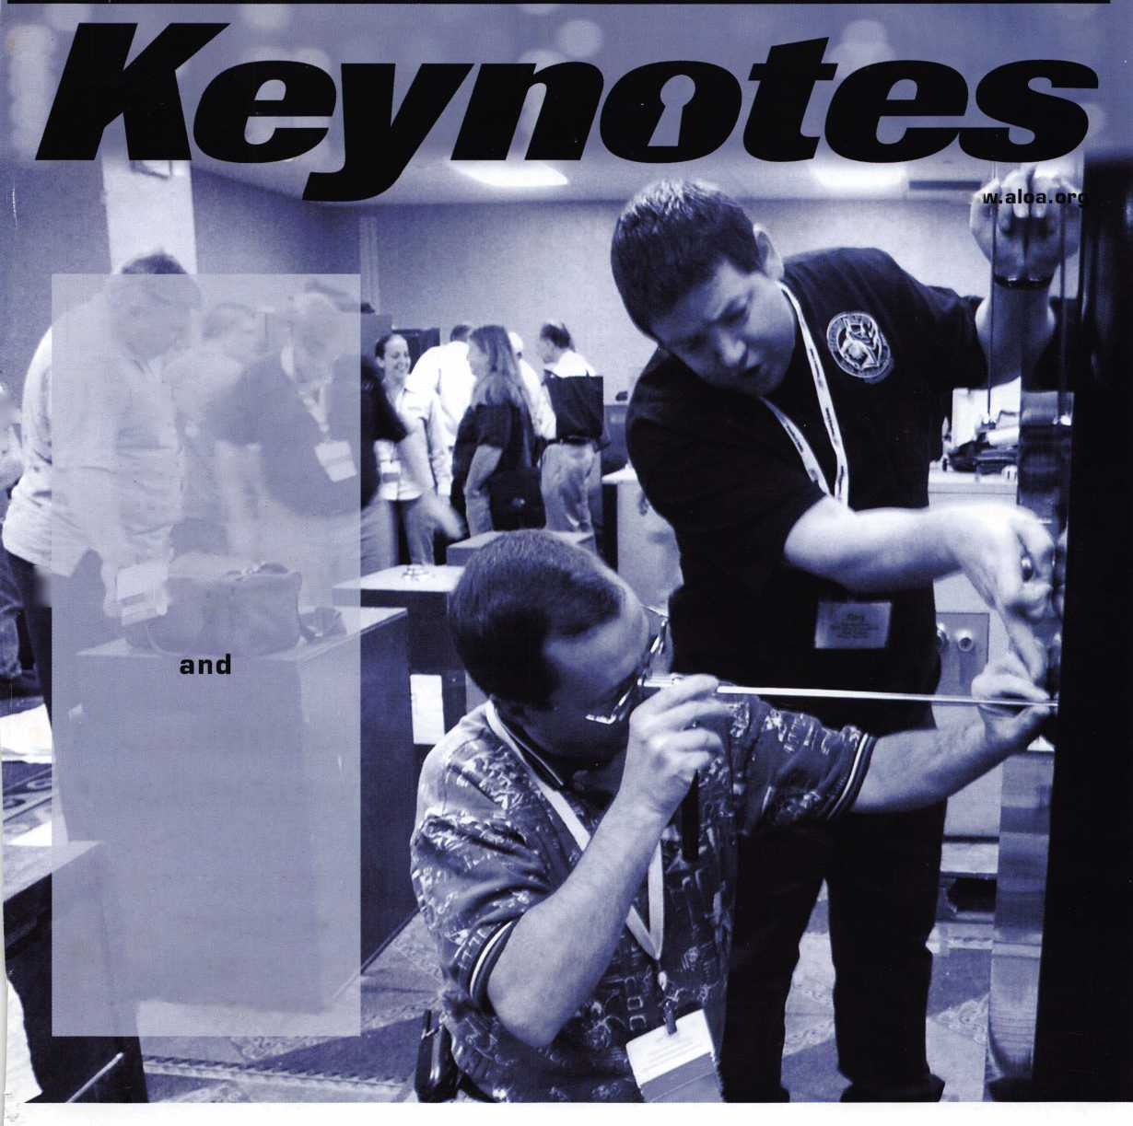

OUR STAND

**IT’S QUITE POSSIBLY YOUR MOST**

**TRUSTED SIDEKICK**

Keep it in Good Hands® with Allstate

quick certificates of insurance, ID cards, assistance with the claims process, and more. All from one of the most widely recognized names in the business.

Are you in Good Hands®?

As a small business owner, there are few things you rely on more than your vehicle to keep you going Your local Allstate agent can help protect it and your small business with services you need including

1-800-859-0247

CALL NOW TO LOCATE YOUR NEARBY ALLSTATE AGENT.

You’re in good hands.

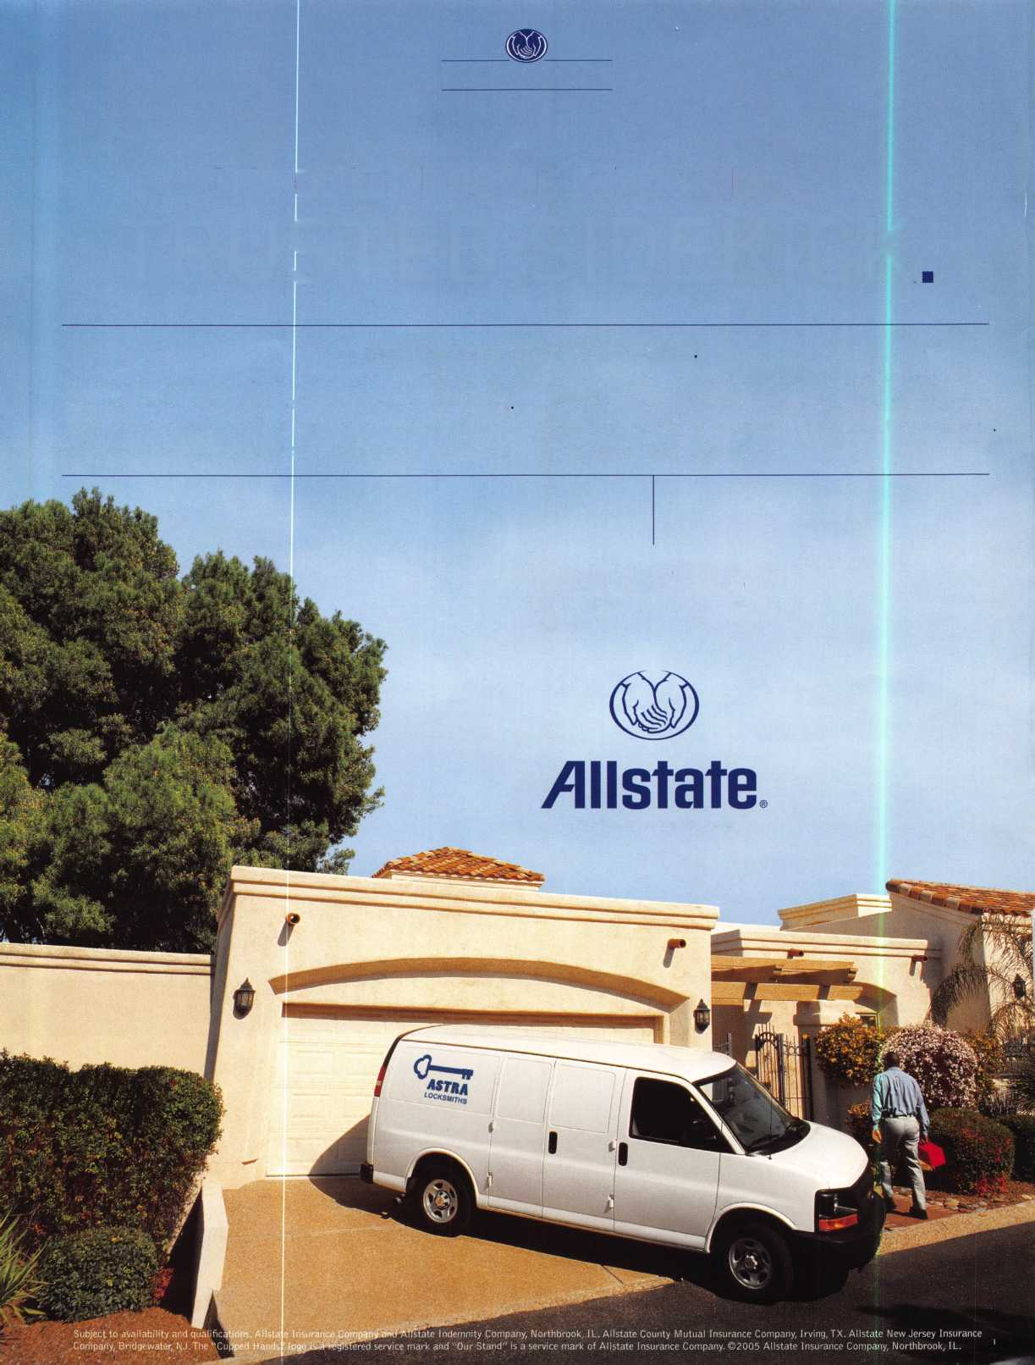

A Name You Know

As a business owner, you know the importance of a  
good name. Your name is your reputation. Your name  
stands for all that you offer in products and services.  
It’s a symbol of who you are. So, we thought you  
might like to know that Allstate, the name you know  
for insuring your personal vehicle and your home,  
also offers a business auto policy to help protect vehi-  
cles used in your locksmith business.

The following are coverages typically included in  
our business auto policy that might be important to  
you as a business owner:

Business Auto Liability coverage

* Higher limits up to $2,000,000 per occur-  
  rence.
* Protects you if you are legally responsible  
  for injuries and damages arising out of  
  the ownership, maintenance, or use of  
  business vehicles.
* Cost is based on several factors, including  
  garage location, type and use of vehicle,  
  and the violation and accident activity of  
  your drivers.
* Additional Insured coverage may be  
  required when you contract with govern-  
  mental agencies or bid on local  
  commercial jobs.
* Generally not available on a personal auto  
  policy.
* Usually is no charge to add an insured to  
  a Commercial Auto policy.

Hired Auto coverage

* Provides liability coverage for those  
  vehicles you rent, hire or borrow for  
  business use.
* The premium for hired auto liability  
  coverage is based on the estimated  
  annual rental cost.
* Tools and Special Equipment
* Provides protection to permanently  
  attached equipment on your vehicle.
* You will need to let your agent know the  
  value of the equipment to include in the  
  cost of the vehicle.

You’re good at your business. Your insurance com-  
pany should be the same way.

Contact an Allstate agent to discuss your business  
auto insurance needs. To be referred to an agent,  
please call 800.859.0247 or email

**[abisO@allstate.com](mailto:abisO@allstate.com)**.

Subject to availability and qualifications. Insurance coverage  
is subject to policy terms.

Allstate Insurance Company

Allstate Indemnity Company  
Northbrook, IL

Allstate County Mutual Insurance Company  
Irving, TX

Allstate New Jersey Insurance Company  
Bridgewater, NJ

allstate.com

© 2005 Allstate Insurance Company, Northbrook, IL

Get What's  
Coming To You

AIOA continues to provide you with this and other great benefits and services!

310**-**575-5027

Just call 310-575-5027

1. ALOA Index of Documents
2. Becoming a Locksmith (Ipg)
3. Locksmith Career Summary (3pg)
4. Locksmith School List (3pg)
5. ACE Class Schedule (Ipg)
6. Certification Information(Ipg)
7. PRP Category List (1 pg)
8. ALOA Membership Application^ pg)
9. ALOA List of Benefits (Ipg)
10. Scholarship Application Form (Ipg)
11. ALOA Video Library Order Form (1 pg)
12. ALOA Membership Items Order Form (Ipg)
13. Safe & Vault Technicians Association Member

Application/Subscription Form (2pg)

1. Recertification Information (3 pg)
2. Legislative Action Network (2pg)
3. Various State Laws
4. Industry Position Pager (Ipg)
5. ALOA Convention and Class  
   Schedule/Descriptions (33 pg)
6. Board of Directors Nomination Form
7. ALOA Convention Registration Form

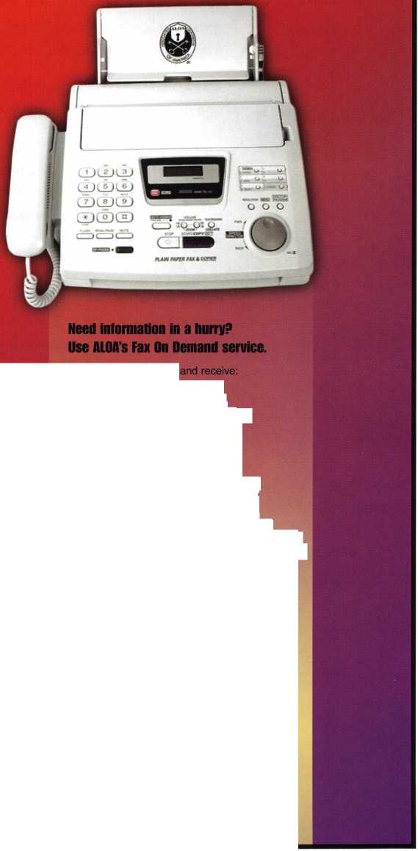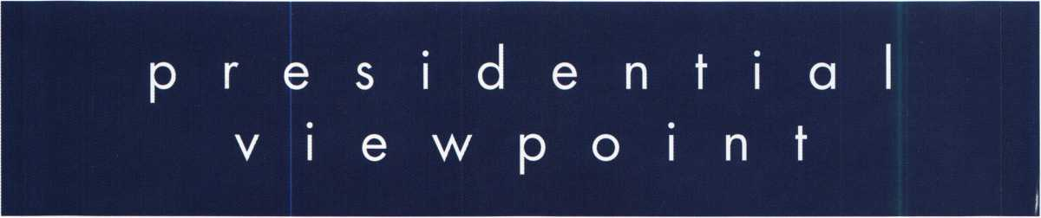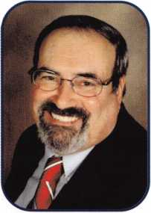

Dear Members,

Ah, Spring! A time of renewal! Its presence is felt in the atmosphere. Bright flowers, new green grass, mild zephyr winds blowing, new fresh green leaves on the trees—Can you tell that spring­time is one of my favorite times of the year?

Spring combined with association activity makes for a very busy season. So many conventions and meetings are held at this time of the year. It's time to infuse our associations with that spring­time feeling.

This is the perfect season for a renewal of commitment to our profession. A time for new people to step up and volunteer to run for offices or chair committees. When we create that kind of momentum within our local associations, we indeed create our own zephyr wind that tends to keep our thoughts fresh and our members involved. New ideas bloom that benefit our associa­tions and all the members.

Along that same thought, "fresh and new", we should try to improve our image. We can all benefit from sprucing up our appearance. The public sees our dress and makes assumptions as to whether or not we are professionals or just part-time fix it people. A clean, neat appearance goes a long way to reaching that goal in raising our profession in the eyes of our customers. Clothes do not make the person, but the image put forth long remains in the thoughts of the public.

A heads up for all, a dress code will be strictly enforced at our convention. Now before we all start moaning that it will be hot and I'm on vacation, just remember, the dress code is not there to make you uncomfortable, but is intended to portray our membership as the proud, professional organization that we know it to be—an association dedicated to the security of the world.

On that note. I'm off to mow the lawn and enjoy the sights and sounds of spring!

Take 'er easy!

Sincerely,

Robert E. Mock

Keynotes • April 2006

SCHLAGE

**CAL-ROYAL**

DOR-O-MATIC

**MONARCH**

I

**VisalacK**

(ffiL.

OLYMPUS^

LOCK, INC.

**SARGENT**

**DONJO**

A RROW

**LOCKCRAFT^j**

**BIANCHI**

I LAB IMA f OR

**PRD-LDK**

***an.***

*HATA^T*IOC  
*^ HnnSm*

***Peterson***

COBRA

**IMERIOIN**

**LOCK**

*LAS VEGAS CONVENTION CENTER*

*AUTOMOTIVE*

A1MKMitl **LOEKCRAFT^j**

" '' ***DETERMINATOR***

„„ ***MAJOR*** *HATA*

**— PRD-LOK**

TC^fttk *Wedgaar™*

*ACCESS C0HTR01*

***Peterson***

|  |  |
| --- | --- |
| EXIT T-Bird"l  Booth 1 | EXIT |
| HL^jfge Co. |  |

© © © o © © ©

© o © © © © ©

N * © © N ©

**Ui** 111 **Ul IU Ul Ui**

**-*l -J -J «J**

2 £ £ £ £ £ aloa

**5 5 5 5 5 5l„B00f/iJ**

**Ui Ul Ul Ul**

**•J «J «J**

« « « « ,

**Entrance i**

***Extremely Competitive***

***E/Z Free Freight Minimums***

***Same Day Shipping  
Service with a Smile  
High Fill Rate  
Hard to Find Items***

**\***

*\**

*\**

***\****

***\****

**\***

ii

I *0'%*

■ ***dtp'"'***

■

**E/Z *Order Web Site '&* :L**

***VTWW.HLFLAKE.com***

***Order 24 hours a day Updated Every Business Day Extra Discount for Web Orders Personalized Inventory Lists***

***LOG ON TO...***

[WWW.HIFLMKE](http://WWW.HIFLMKE). com

(lifts* Wftta tftftft

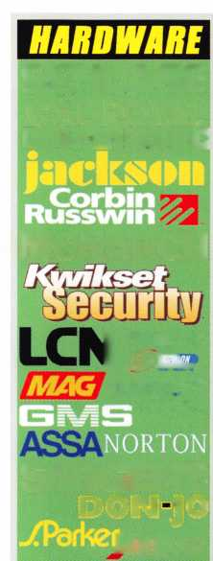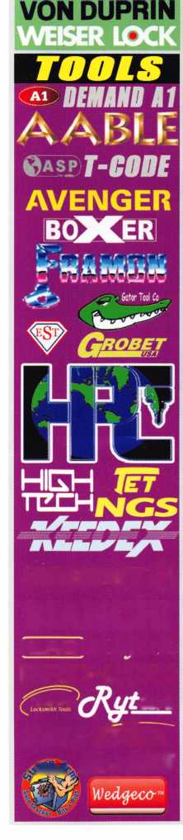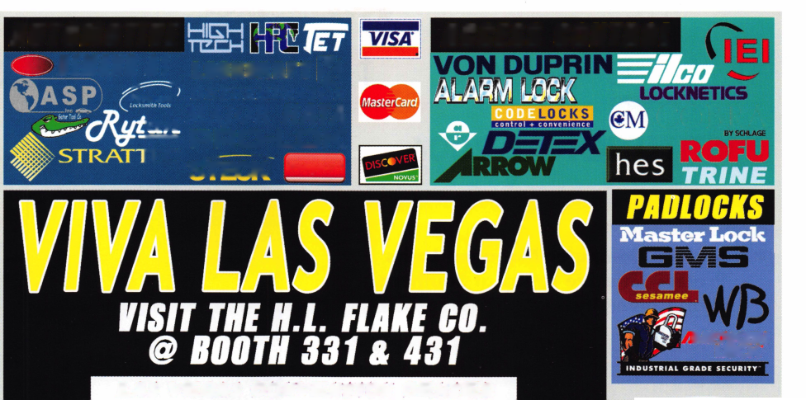

feat

INSTITUTIONAL 2006

10

Schlage Computer-Managed Locks Protect Sensitive Areas at Southern Utah University

Computer-managed locking systems provide features found traditionally with online, networked systems.

**16**

Forensics

Out of the ashes comes the truth. Find out how forensic locksmiths help uncover insurance fraud.

by Don Cunningham



An Interesting Call

Read on to find out what made this call so interesting.

by Thomas Stern

**22**

SAFETECH 2006 REVIEW

Catch the highlights of this years SAFETECH convention.

**28**

Mosler Retro

Greg Perry is called upon when a customer needed the interior jewelers chest of a Molser heavy wall cast iron opened so he could retrieve the contents and throw away the safe. Find out what happened.

by Greg Perry CML, CPS

u r e s

|  |  |  |
| --- | --- | --- |
| r |  |  |
| AD INDEX |  |  |
| Allstate Inside Front Cover | |  |
| Fax on Demand | 1 |  |
| E-Key | 1 |  |
| HL Flake | 3 |  |
| Safetech 2007 | 7 |  |
| IR | 13 |  |
| Service Magic | 15 |  |
| ALOA 2006 | 19 |  |
| A&B Safe | 23 |  |
| CCL | 27 |  |
| ALOA Member Recruitment | 31 |  |
| Harry C. Miller Ad | 33 |  |
| SafeData | 34 |  |
| Jameson Code | 35 |  |
| Clearstar | 42 |  |
| PBP | 42 |  |
| Payment Retriever | 42 |  |
| Turn 10 | 42 |  |
| Ultralift | 43 |  |
| FKI | Back Cover |  |
| L |  |  |

**Departments**

|  |  |  |  |  |  |  |  |  |  |
| --- | --- | --- | --- | --- | --- | --- | --- | --- | --- |
| Presidential |  | Exect | jtive | 5 | Calendar | 8 | Classified | 36 | Legislative 40 |
| Viewpoint | 2 | Appl | cants .... | 6 | Core | 9 | Associate |  |  |
|  |  |  |  |  |  |  | Members | 38 |  |

Visit our NEW website at [www.aloa.org](http://www.aloa.org)

**executive**

Volume 52, Issue 4

Additional contact information for the ALOA Board and most Keynotes authors is  
available through "Locksmith Search" on the ALOA Web site- [www.aloa.org](http://www.aloa.org) or by  
contacting the ALOA office at 3500 Easy Street; Dallas, TX 75247; (800)532-2562;

FAX (214)819-9736; e-mail [aloa@aloa.org](mailto:aloa@aloa.org).

Editor

Betty Henderson [betty@aloa.org](mailto:betty@aloa.org)

Advertising Sales

Kim Hammond voice: 817-645-6778

Fax: 817-645-7599 e-mail: [adsales@aloa.org](mailto:adsales@aloa.org)

Executive Director

Charles W. Gibson, Jr., CAE [charlie@aloa.org](mailto:charlie@aloa.org)

Associate Executive Director

David Lowell, CML, CMST [david@aloa.org](mailto:david@aloa.org)

Convention & Meetings Manager

Jo Anne Mims [joanne@aloa.org](mailto:joanne@aloa.org)

Operations/Membership Manager

Mary May [mary@aloa.org](mailto:mary@aloa.org)

Director of Creative Services

Betty Henderson [betty@aloa.org](mailto:betty@aloa.org)

IT Operations Manager

Greg Jackson [greg@aloa.org](mailto:greg@aloa.org)

Comptroller Kathy J. Romo

Membership Coordinator Shelly Jett

Convention & Meetings Assistant Karen Lyons

PRP/Education Coordinator Mayra Ocon

Mail Room Coordinator Kevin Wesley

Creative Media Specialist Margarita Garza

Accounting Coordinator Joyce Nixon

Executive Assistant Sue Langford

Assistant Education Manager Bob Stafford

Legislation Manager Tim McMullen

Receptionist Shelley Melton

Contributors

Jerome Andrews, CML  
Paul Chandler, CRL  
Claire Cohen, CML  
Brian Costley, CML, CMST  
Eric Costley, CRL

Ray D'Adamo, CML Billy Edwards, CML Dan Graffeo, CRL,CMST Jim Hancock, CPL Jeff Nunberg, CML, CMST

Randy Simpson, CML, CPP Robert Stafford, CML Dave Thielen, CML Greg Perry, CML,CPS

Tom Seroogy

Charles Stephenson, CPS

Dennis Watanabe, CML, CMST

Mission Statement: The Associated Locksmiths of America, Inc. is dedicated to enhancing the professionalism, education and ethics among  
locksmiths and those in related sectors of the physical security industry. With approximately 10,000 members in the United States, Canada and the  
freeworld, ALOA is poised to help members obtain the knowledge, the strength, and the confidence to perform their role in the physical security field  
with pride and dignity. But it is only through active involvement and participation that ALOA can fully achieve its potential —and can help members to  
achieve theirs.

Policies: Keynotes® is the official publication of the Associated Locksmiths of America, Inc. (ALOA). Keynotes9 acts as a moderator without approving,  
disapproving, or guaranteeing the validity or accuracy of any data, claim, or opinion appearing under a byline or obtained or quoted from an acknowl-  
edged source. The opinions expressed by the authors do not necessarily reflect the official views of ALOA. Also, appearance of advertisements and  
new products or service information does not constitute an endorsement of products or services featured by the Association. The Association does not  
accept responsibility for the inaccuracy of any data, claim, or opinion appearing in this publication, due to typographical errors on the part of the  
authors, Association staff or its agents.

Editor's Note: This publication is designed to provide accurate and authoritative information in regard to the subject matter covered. It is provided  
and disseminated with the understanding that the publisher is not engaged in rendering legal or other professional services. If legal advice and other  
expert assistance is required, the services of a competent professional should be sought.

Authors' Payment: Payment for eligible submissions to Keynotes will be based on the following criteria: topic, time spent and past contributions. Authors who  
regularly submit to Keynotes® are generally paid a higher rate. The latter is especially true of authors who write to fit specific editorial needs and submit said copy  
by Keynotes® deadlines. As a general guideline: Average payment for a 750 word, business or 'light' technical article would be $200. Payment for a 1500 word  
article involving significantly higher time and research efforts would be $400.

Payment will not be offered for articles submitted by ALOA employees or members of the ALOA Board of Directors (unless material is of a technical  
nature), nor for articles submitted by a company that promote that company's products or services. ALOA reserves the right not to pay for articles sub-  
mitted by an individual(s) that promote a particular company's products or services.

Disclaimer: The Associated Locksmiths of America, Inc., (ALOA), reserves the right to refuse any article for any reason. Additionally, ALOA reserves  
the right to edit, amend or modify any article submitted for publication in order to preserve technical accuracy, clarity, fairness or grammatical cor-  
rectness. ALOA will make the best efforts to notify the author of any changes. The extent of ALOA's liability for any article or information contained  
therein will be a notice of correction or retraction in the next possible issue.

Keynotes® (ISSN 0277 0792) is published monthly except for the combined June/July issue by The Associated Locksmiths of America, Inc.,  
3500 Easy St., Dallas, TX 75247-6416. Telephone: (214) 819-9733; FAX (214) 819-9736; e-mail [aloa@aloa.org](mailto:aloa@aloa.org). Subscription rates for  
members —$15.00 per year. Periodical class postage paid at Dallas, Texas. POSTMASTER: Send address changes to: Keynotes, 3500 Easy St., Dallas,  
TX 75247-6416. © Copyright 2003, All rights reserved. No part of the contents may be reproduced or reprinted in any form without prior  
written permission of the publisher.



President

Robert Mock

(856) 863-0710 [president@aloa.org](mailto:president@aloa.org)

Secretary

John Soderland, CML, CMST (414) 327-5625 [secretary@aloa.org](mailto:secretary@aloa.org)

Directors, Northeast

Peter Sarailian, CRL (201)944-7547 [nedirectdr@aloa.org](mailto:nedirectdr@aloa.org)

Vernon Kelley, CPL

(609)771-3126

[nedirectOr@aloa.org](mailto:nedirectOr@aloa.org)

Directors, Southeast

Tom Gillingham, Jr., CML, CPS  
(615) 264-0747  
[sedirector@aloa.org](mailto:sedirector@aloa.org)

Ken Kupferman, CML

(813)961-5784  
sed i rector@a loa. org

Director, North Central

William Smith, RL  
(920) 893-5282

Guy Spinello, RL  
(815) 394-1000

ncdirector@aloa .org

Director, South Central

CD Lipscomb, CML, CPS  
(903) 874-3522  
[scdirector@aloa.org](mailto:scdirector@aloa.org)

Directors, Southwest

Gordon R. Racine, CML  
(719) 384-4707  
[swdirector@aloa.org](mailto:swdirector@aloa.org)

Julie McCluney, CRL  
(714)636-5652  
swd i rector@a loa. org

Director, Northwest

Jim Jeffries, CPS  
(877) 241-6978  
[nwdirecfor@aloa.org](mailto:nwdirecfor@aloa.org)

Director, European

Hans Mejlshede, CML  
(453) 539-3939  
[eurdirector@aloa.org](mailto:eurdirector@aloa.org)

Director, Asian

JoeJ. Lee, CRL  
(215) 289-2404  
[asiandirector@aloa.org](mailto:asiandirector@aloa.org)

Director, Associate

Paul M. Jusfen  
(612)238-4646  
asdirector@aloa. org

Trustees

[trustees@aloa.org](mailto:trustees@aloa.org)

Randy Simpson, CML  
(281) 240-5959

JohnJ. Greenan, CML, CPS  
(773) 486.2030

William Young, CML, CPS  
(610) 647-5042

Past Presidents

2003-2005 William Young, CML, CPS  
2001-2003 Randy Simpson, CML  
1999-2001 John Greenan, CML, CPS  
1997-1999 Dallas C. Brooks  
1995-1997 David Lowell, CML, CAAST  
1993-1995 Breck Camp, CML  
1991-1993 Henry Printz, CML  
1989-1991 Evelyn Wersonick, CML, CPS  
1987-1989 Leonard Passarello, CPL  
1985-1987 Joe Jackman, CML  
1983-1985 Stanley Haney, CPL  
1981-1983 Louis LaGreco, CPL  
1979-1981 John Kerr, RL  
1977-1979 Clifford Cox, CML  
1974-1977 Charles Hetherington  
1972-1974 Gene Laughridge  
197G1972 William Dutcher, RL  
1968-1970 Constant Maffey, RL  
1966-1968 Harold Edelstein, RL  
1964-1966 William Meacham  
1962-1964 Robert Rackliffe, CPL  
196G1962 Edwin Toepfer, RL  
1956-1960 Ernest Johannesen



Keynotes • April 2006

AR

KY

OK

s

P

Bentonville

Eric Casey

Sponsor: Clifford D. Lipscomb CML, CPS Jerry Cosey

AZ

Chandler

Preston M. Scheier

Sponsor: Enrique B. Olivares Yuma

Don R. Williams

CA

La Quinta

Marko Jermy

CT

Bristol

Thomas Martucci

Sponsor: Michael D. Sigmund

FL

Deltona

Anthony Gonzalez

Tampa

Kevin E. Rimes

Sponsor: Nick Ray Jr, CPL

Stockbridge

Edward D. Hanes

Sponsor: John C. Elliott Jr, CML, CPS Woodstock

Joseph C. Grimes

Sponsor: John C. Elliott Jr, CML, CPS

IN

Portland

Robert Byers Jr

Sponsor: Jim Williams CRL

ks

Hutchinson

Steven R. Crile

Sponsor: Elvis D. Hammerschmidt CPL Kansas City

Eldon E. McKee Jr

Sponsor: Mark L. Stewart CRL

|A

Scott

Reynaldo Gonzalez

Sponsor: Brad Kistler

Lexington

Elizabeth K. Cox

Sponsor: Tim Abner

IMP

Mount Airy

Timothy Delisi

Rockville

Jerome T. Peck CPL

Silver Spring

Christopher C. Roberts

Sponsor: Michael B. Groves

Ml

Wayne

Kevin G. Smith Jr

Sponsor: Thomas J. Lewis CPL

MN

Willmar

Alvin L. Nohl

MT

Bozeman

Ian A. Maguire

Sponsor: Richard O'Donnell Missoula

Mark M. McMillin

Sponsor: James M. Watt CML, CPS

NC

Charlotte

Frank Larmand

Sponsor: Frank P. McGrath CRL Mooresville

Mark Ahuna

Sponsor: Ralph E. Fuller

ND

Lumberton

Jimmy N. McKee

McLeansville

R David Ingle

Washingtonville

Karl Steger

Sponsor: Roy Brachfeld Williston Par

Gary Sofferman

Sponsor: Joel S. Kramer

Eufaula

Jim Whitney

TX

Abilene

Dennis R. Boeshart

Sponsor: Steven S. Sandlin Austin

Mark Leonard

Sponsor: James L. Hancock CPL Bedford

T.J. Donnelly RL

Sponsor: Clifford D. Lipscomb CML, CPS Dallas

Donny W. Dyess

Sponsor: Clifford D. Lipscomb CML, CPS Houston

Philip Alexander

Mathis

Kenneth R. Smith Jr

Sponsor: Steven S. Sandlin

VA

Arlington

Steve Walker

Sponsor. Michael B. Groves Martinsville

Derek McGee

Sponsor. Gary McGee

VT

Irasburg

Richard W. Davis Kenneth B. Johnson

WA

Tacoma

Stephen Ferguson

WV

Nitro

Troy Mynes

Sponsor Vernon C. Mils

Great Britain

Bristol

Leigh L. Ridgway

Sponsor. Ken Dale

Norwa>

Honefoss

Bruce Burby

These applicants are scheduled for clearance as members of ALOA. The names are published for member review and comment within 30 days of this Keynotes issue date, respectively, to ensure  
applicants meet standards of ALOA's Code of Ethics. Protests, if any, should be addressed to the Membership Department and must be signed. Active Membership applicants (a) have worked in  
the industry two or more years. Allied Membership (AL) applicants are not locksmiths, but work in a security-related field. Apprentice Membership (AP) applicants have worked in the industry less than two years.



Keynotes • April 2006



b^,Mr

**IAS VEGAS**

|  |  |
| --- | --- |
| rrii i | | r fll |
| S 89 i | Hi |

£ver V

b0dV Wa«ts

**FKI**

SECURITY GROUP

**(Of) security&Safety**

**Cbm^C**

SECURITY PRODUCTS

**.. You** MIGHT TAKE

IT HOME!

One Lucky Member Attendee at ALOA  
2006 is going home with this gorgeous  
mint-condition 1956 Ford Thunderbird.

A ticket will be given to each ALOA  
Member who registers and attends the  
show. Someone has to win it, and it  
might as well be YOU!

(Must be present to win. Exhibitors,  
Employees. Family Members of Employees, and  
nonmembers **are not** eligible for this door prize.)

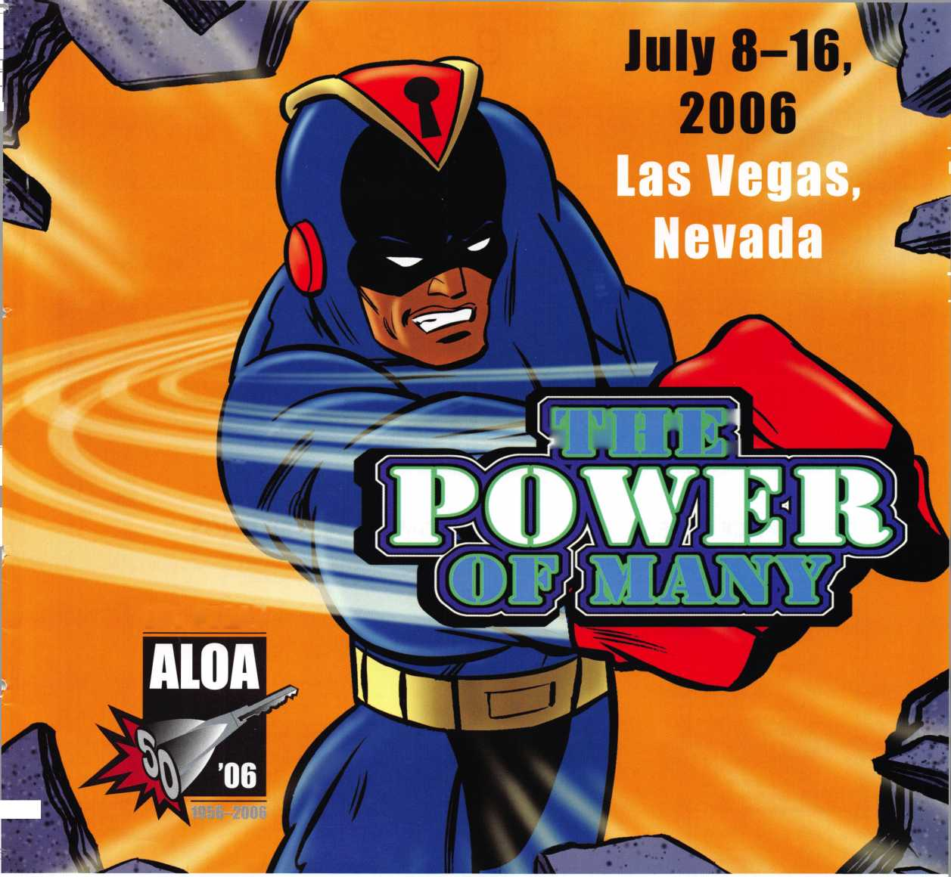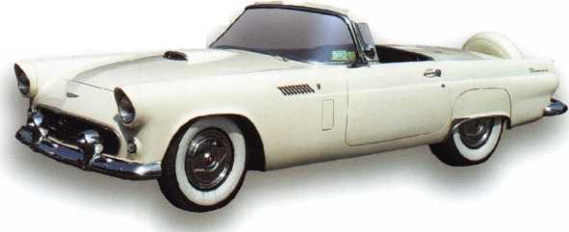

**upcoming**

**events**

|  |  |  |
| --- | --- | --- |
| 5-7 ISC West | 5-9 European Locksmith Federation | 22 Virginia Locksmiths Association |
| Las Vegas, NV | [www.eurolockfed.com](http://www.eurolockfed.com) | Transponder Class |
|  | Venice, Italy | Chester, VA |
|  |  | Contact: Elliot Conner |
|  |  | email: [va_locksmith@cox.net](mailto:va_locksmith@cox.net) |

Q.

<

|  |  |  |  |  |  |
| --- | --- | --- | --- | --- | --- |
| $  s | 6-7 Oklahoma Master Locksmith Assc 2-day session  Contact: Mike McGrew, CRL 918-333-9136  Tulsa, OK • Holiday Inn Select |  | | | |
| ui  Z  D | 11 North Jersey Master Locksmith As 12th Annual Flea Market  Sunday, 9am - 1 pm  Contact: Jeff Sitar 973-777-0620 or Pete Sarailian 201-944-7547 | 1 | | | |
| JULY | 7/8-16 Associated Locksmiths of Ar  ALOA 50th Annual Conven Las Vegas, NV  Contact: 800-532-2562 or | nerica  tion & Security Expo  visit [www.aloa.org](http://www.aloa.org) |  | SOON | 9/15-16 Doyle Security Products  20th Annual Trade Show & Educational Weekend  Minneapolis, MN  Contact: Chantelle Gallagher  800-333-6953 |

**UPCOMING ACE CLASSES**

4/22-23/2006 White River Junction, Vermont • ACE Classes  
Green Mountain Locksmiths Association  
Contact: Bradley Manchester  
802-863-4153

4/22-23/2006 Fort Wayne, Indiana • ACE Classes  
Northern Indiana Chapter of ALOA  
Contact: Jeremy Rodocker, CML, CPS  
260-459-1500

5/13/2006 Detroit, Michigan • ACE Classes

Locksmiths Security Association  
Contact: Robert C. Nobel, CPL  
810-385-9329

**UPCOMING PRP SITTINGS**

|  |  |
| --- | --- |
| 4/01/2006 | Saturday 8:00 am • Ontario, CA • California Locksmiths Association Suzanne Harmony 714-632-6800 |
| 4/06/2006 | Thursday 9:00 am • Dallas, TX • ALOA  Mayra Ocon 800-532-2562 x203 |
| 5/11/2006 | Thursday 9:00 am • Dallas, TX • ALOA  Mayra Ocon 800-532-2562 x203 |
| 6/08/2006 | Thursday 9:00 am • Dallas, TX • ALOA  Mayra Ocon 800-532-2562 x203 |
| 7/13/2006 | Thursday 6:00 pm • Las Vegas, NV • ALOA 2006  Mayra Ocon 800-532-2562 x203 |

'

7/8-16/2006 Las Vegas, Nevada • ACE Classes

ALOA 50th Annual Convention & Security Expo Contact: ALOA Education [education@aloa.org](mailto:education@aloa.org) [www.aloa.org](http://www.aloa.org)

8/23-28/2006 Dallas, Texas • ACE Classes

Associated Locksmiths of America Contact: ALOA Education education@aloa .org [www.aloa.org](http://www.aloa.org)

8/26/2006 Saturday 3:00 pm • Dallas, TX • ALOA

Mayra Ocon 800-532-2562 x203

9/7/2006 Saturday 9:00 am • Dallas, TX • ALOA

Mayra Ocon 800-532-2562 x203

**Contact the ALOA Education Department for a list of classes and training offered in-house.**

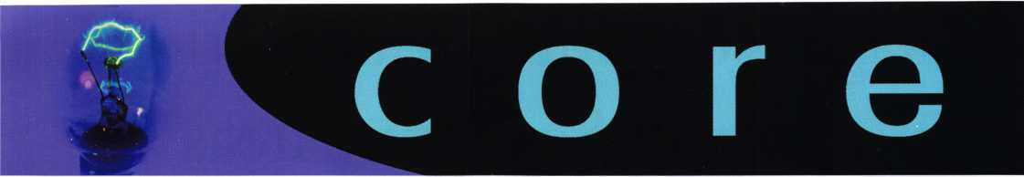

**New** Product

DORMA Glas now offers a stylish Double-Action Hinge. The fully adjustable hinge offers the curved architectural element inspired from the award winning ARCOS design system.

The ARCOS line of hardware for tempered glass doors features flowing lines and elegant design to offer archi­tects and designers an exquisite complement between metal hardware and tempered glass doors. The metal products in the ARCOS line have an arc-like curvature that seamlessly blends the hardware into the glass. Each ARCOS component shares the same area radius. The result is a clean, stylish, tasteful appearance.

The Double-Action Hinge includes adjustments for spring tension and angle adjustment for aligning the door to the zero point. The heavy-duty hinge is appropriate for low and high-frequented doors and can be specified in a hold open position at 90°.

The hinge can be used for 3/8" and 1/2" thick glass. The Double-Action Hinge is available for a maximum door width of 40" and maximum weight capacity of 143 lbs.

For more information or a product brochure, call DORMA Glas at 1-800-451-0649 or visit [www.dorma.com/usa](http://www.dorma.com/usa).

Previous Article

The CM500 battery control unit used in the application described in the February 2006 Keynotes article is no longer available. There is no replacement for it for bat­tery use. The manufacturer continues to support the units, replacing the key pad and the latch when needed. However, when the control panel fails, another product must be substituted.

Locksmiths in the News

Visit this website for an article describing the benefits of using ALOA locksmiths

[www.wtopnews.com/index](http://www.wtopnews.com/index). php?nid=25&sid=717697

Mul-T-Lock is proud to announce a new product to its line, the MDS600!

This is not just another digital, keypad lock using a lever and a latch. This is probably the only no wired digital lock in the market that offers a bolt and a high security over-ride cylinder.

The MDS600 is a unique digital lock compared to other digital locks, because of its security bolt. The MDS600 is equipped with a high security mechanical cylinder for key override. One of its best features is the backlighting digital keypad display for nighttime operation.

NEW ASSA ABLOY RETROFIT SECURITY SOLUTIONS ALLIANCE ANNOUNCED

ASSA ABLOY High Security & Aftermarket Group President Tom Kaika recently announced the launch of a new sales and marketing organization—ASSA ABLOY Retrofit Security SolutionsSM (RSS) — formed by merging the sales and marketing operations of Medeco Security Locks and Arrow Lock & Door Hardware.

The new Retrofit Security Solutions organization will offer professional locksmith dealers and distribution partners the widest selection of high security and aftermarket products available from both the Medeco and Arrow brands. RSS will drive accelerated product development, increased end user focus, and the elimination of redun­dancy leading to improved communication and more cohesive partner programs and support.

RSS will operate under the joint leadership of Director of Marketing Noel Flynn, and newly hired Director of Sales Brian Strom. Strom comes to RSS with more than 16 years of security industry experience.

"Overall, our sales personnel will be able to better focus on and react to local market conditions," Kaika said. "This enhanced focus aligns us with ASSA ABLOY's strategic commitment to value-added distribution while placing an emphasis on innovative products that satisfy end users' security needs."



Keynotes • April 2006

Schlage Computer-Managed Locks Protect Sensitive Areas at Southern Utah University

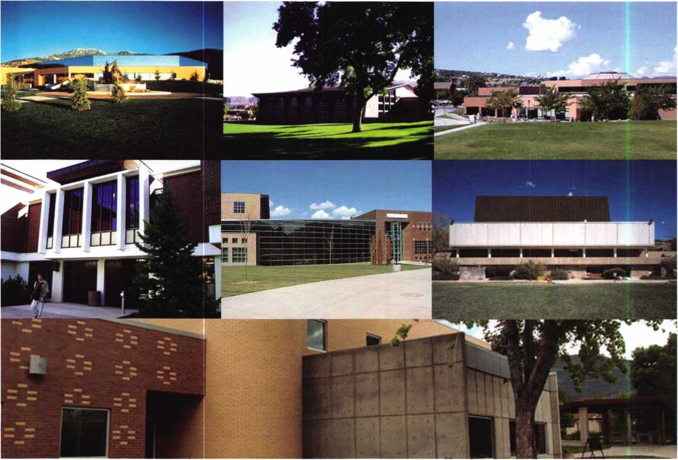

Southern Utah University is using Schlage Computer-  
Managed (CM) locks to secure offices, computer labs and  
the lock shop itself at the 100-year-old regional university.

Schlage CM standalone locking products provide features  
found traditionally with online, networked systems. User-  
friendly software on a laptop or PDA programs the locks,  
access trim, and offline hard-wired controllers, which man-  
age strikes and magnets. New users, access points and

access privileges can be  
programmed into a CM  
lock in seconds. Users  
can select proximity, mag-  
netic stripe, PIN or i-  
Button credentials indi-  
vidually or in combina-  
tion. The CM lock also  
provides an audit trail for  
download onto a laptop  
or PDA.

“The CM locks make it  
possible for more people  
to have access to other-  
wise locked rooms,"  
reports Jake Seiler,

Assistant Locksmith at  
Southern Utah University.

"Department heads also  
want to know who has  
access for security reasons.

The university owns com-

puters and big, expensive equipment in the computer labs  
and elsewhere that need extra protection."

CM locks are placed on wood and metal doors at two  
building entrances, computer labs, offices and the lock  
shop. The CM locks prevent people from entering the  
lock shop and stealing keys to gain access to other facilities.

"It is a lot quicker to add people. It takes about 10 sec-  
onds and you're done," Seiler notes. "It's much more effi-  
cient than keys. The locks are easy to use, uncomplicated,  
and you can carry less stuff around. We've had an imme-  
diate, good response from users as well."

Southern Utah University uses magnetic stripe cards with  
the CM locks, along with i-Buttons. The magnetic stripe  
cards are also used for accessing library services, meal plans

and the student store on  
campus.

"We definitely plan on  
using more CM locks on  
campus," Seiler adds. "We  
are getting more and more  
requests for the locks. For  
instance, we just put one in  
on a computer lab, and we  
are recommending them to  
other departments as well."

About Southern Utah  
University

Through its more than 100-  
year history, Southern Utah  
University has evolved from  
a teacher training school  
into its current role as a  
comprehensive, regional  
university. It serves the

southern region of Utah and the contiguous counties of  
two states with undergraduate and graduate programs and  
applied technology training. People of the region look to  
the University for outreach services, culture, economic and  
business development, public education, regional history,  
public affairs, and major academic specialties.

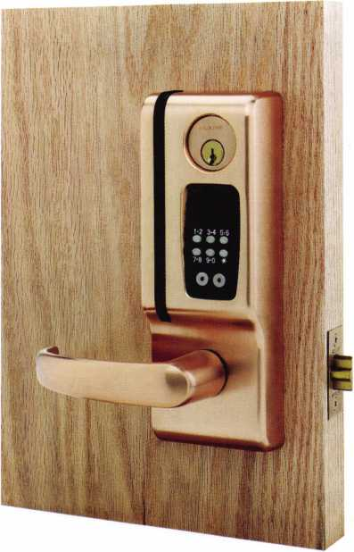

Everyone in the lock shop has learned how to program the locks with LockLink 3.0 software. Seiler and his staff use PDAs to download information off of a PC and upload it to the locks.

Keynotes • April 2006

U.S. Military Secures Middle East Base Camps Using Biometric Handreaders

Portable, Turnkey Solution Provides Access Control in Harsh Conditions

The U.S. military is using its biometric Schlage Recognition Systems Handreaders housed inside a custom portal to ensure only authorized individuals access base camps in the Middle East. Handreaders automatically take a three-dimen­sional reading of the size and shape of a hand and verify the user s identity in less than one second. They are not affected by dust, dirty hands, and minor injuries, which can cause false rejects with other biometric technology.

"The military used the Handreaders as a beta test in the the­ater for nine months and had excellent results,” says David Slagel, President of Modular Security Systems Inc. (MSSI), the integrator (Ironton, Ohio). "They specifically requested the HandKey model because of its reliability, accuracy and durability. The HandKey unit is then placed inside our pro­prietary Modular Access Control (MAC) portal, which pro­vides turnstiles and an access control infrastructure.”

The resulting portable, turnkey access control portals are plug-and-play, fully integrated security systems planned for military bases throughout the world. To install a MAC por­tal, military personnel simply set it in place and plug it into 220-power in a junction box. Since the units are portable, the military can establish a “moving perimeter,” widely used in base construction.

“When they finish with one site, they can simply pick up the portal and move it to the next site,” Slagel emphasizes. “For the military, it represents zero construction process. They used to spend $80,000 to $100,000 rebuilding these ‘brass shacks’ each time the perimeter changed.”

Using the portals is also easy. Military personnel enter the portal through one of five roll-up doors. They walk up to the entrance and present a proximity card and then their hand to the Handreader. If the light turns green, they are allowed entrance through the turnstiles. If the light is red, an alarm is sounded that alerts a guard, who then investi­gates.

The MAC portals, featuring the HandKey units, eliminate concerns about the identity of the cardholder or “tailgating,” in which someone simply follows the next person through an access point without proving their identity.

“The proximity card in combination with the biometric identifier virtually eliminates both of these security-compro­mising practices and establishes a higher level of security,” Slagel notes.

New personnel are quickly registered at the MAC itself and the MACs can communicate with each other. There is typi­cally a central MAC and the portals can be linked via a LAN or WAN.

Ingersoll Rand Security Technologies was named recipient of the 2004 Application Market Penetration Leadership Award for access control and time and attendance applications in Frost & Sullivans study, World Biometrics Market.

**12**

Keynotes • April 2006

Real Security Is Knowing There Are  
No Strings Attached. And No Wires Either.

^ When you install Schlage® wireless access control technology in your facility, you  
don't have to replace existing components. After all, this exclusive technology  
is designed to work with any brand of access control system. Utilizing radio  
transmissions instead of wires, it cuts installation time from eight hours to less than  
one and reduces installation costs. Which means you have the confidence of keeping what

works and the freedom to grow beyond it.

Real Security Sets You Free” 33DE3F

[www.schlage.com](http://www.schlage.com)

Out of the Ashes Comes the Truth

By: Daniel Cunningham, JD, CRL, CFL CFATE

The forensic locksmith may be called upon to investigate a variety of situations involving locks. These investigations may be investigation of a burglary, an auto theft or deter­mining the condition of a lock from the debris of a fire. A person who has a background working for a law enforce­ment agency or some other government entity may have an “IN” to gain access to those who are responsible for con­tracting for an outside investigator. This type of work can involve working criminal investigations on a regular basis. Reality and the fact of life is that most of us do not have this “IN” and will receive most, if not all, of our assign­ments from insurance companies.

The majority of assignments from insurance companies will probably be reported auto thefts that are questionable in nature. These are often referred to as an “owner give up” type of theft. The “owner give up” is when, for what­ever reason, the owner of a vehicle takes his vehicle out and destroys it to the degree the insurance company will list it as a “totaled” vehicle. He then reports the vehicle as being stolen to the police and the insurance company.

The reasons a person will fake the theft of their own vehi­cle are numerous and varied. They might have financial problems and be behind on payments; there might be something drastically wrong with the vehicle mechanically (this is a common situation among young “street racers” who have blown up an engine or transmission); or the owner may have crashed the car and not have the proper coverage to get it repaired. In all situations the owner wants to shift the financial responsibility for replacement or repair from him to the insurance company.

The scam is that once the vehicle is “recovered” the insur­ance company rates the vehicle as “totaled” and pays off any outstanding debt on the vehicle or it pays to have the vehicle repaired. Thus the person is free of the debt and his financial record and credit are still intact. The insur­ance company pays for the expensive repairs. Many of the cars are burnt to ensure the car will be “totaled” by the insurance company. So, when the vehicle is completely burnt, how does the forensic locksmith determine if the vehicle was a legitimate steal or an “owner give up”?

The crux of the matter boils down to the ignition lock, the condition of the lock and the location of the lock at the time of the fire. Where was the ignition lock found in the debris of the burnt vehicle? This is the question to be answered by the forensic locksmith. A vehicle that has been completely burned can pose a real challenge for the forensic locksmith. How do you determine anything from the fire debris? Everything is destroyed!

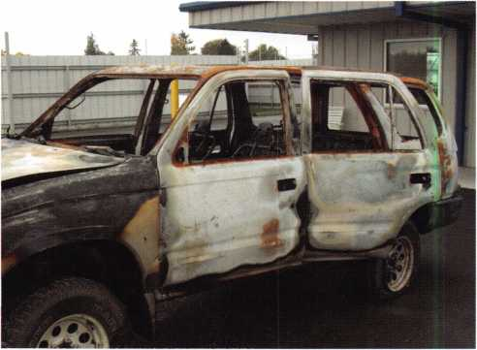

Exterior of vehicle after fire



Keynotes • April 2006

**2 Million**

**at Your Fingertips**

Internet stoppers are looking tor a locksmith Right Howl

ALOA Partners with ServiceMagic? to give members discounted access to leading online marketing solution. Through the relationship, our members will now have access to ServiceMagic's online marketing solution that can dramatically increase revenue and profits.

As an ALOA member, you can now receive targeted cus­tomer leads from consumers looking for a locksmith in your area through ServiceMagic. The program gives you immediate access to ready-to-buy consumers.

* Increase Your Customer Reach - ServiceMagic gets you access to more than 2 million unique visitors and more than 150,000 consumer leads each month.
* Target Your Leads - Get matched consumers looking for locksmiths in only the locations you want to work.
* Increase Your Profits - Service Professionals who have used ServiceMagic for at least a year report grow­ing their business by 28% on average. Many report that ServiceMagic has become their lowest-cost form of advertising.

Free Enrollment Fee for a Limited Time - On behalf of the Associated Locksmiths of America, save $99 by enrolling now.

Unlike other marketing initiatives, with ServiceMagic there are no long-term contracts or ongoing monthly or annual fees. Once in, you pay only for the targeted customer leads you receive. To learn more, please visit: [www.servicemagic.com/ext/771036](http://www.servicemagic.com/ext/771036)

**To learn more, visit**

**<http://www.servicemagic.com/ext/771036>  
or call 888.528.9179**

**SERVICE!**

**MAGIC"**

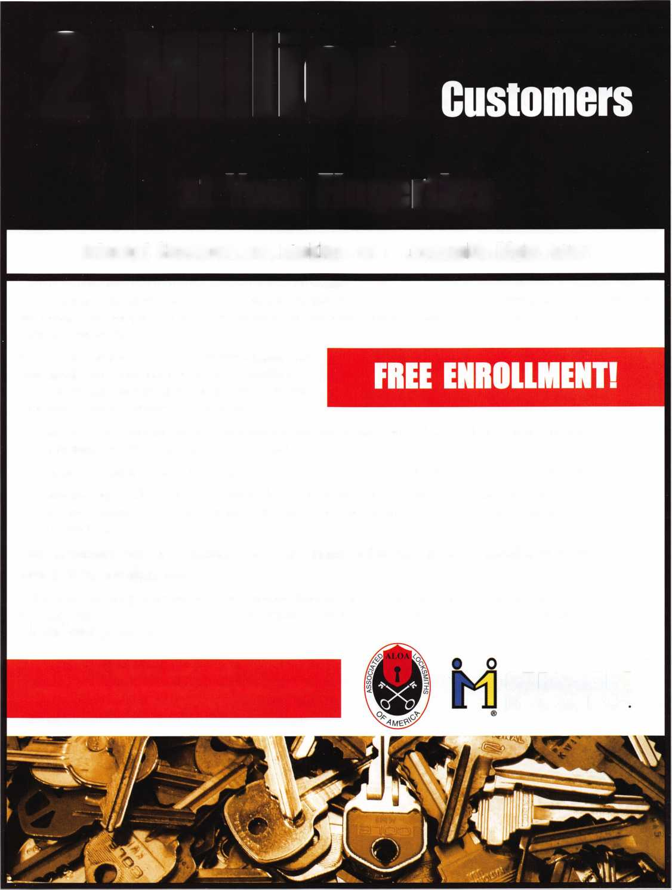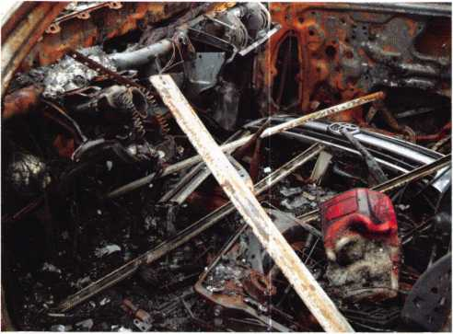

Interior of vehicle showing debris left by fire

The title of this article is the slogan of the International Association Of Forensic Auto Theft Examiners (IAFAE).

It is a very appropriate slogan for a burnt vehicle investiga­tion. A fire destroys most everything in the vehicle and the vehicle itself, but there is always some evidence left in the debris to tell what really happened. It is a matter of dig­ging it out and analyzing it. This is done by the forensic locksmith.

The forensic locksmith is confronted with a big pile of burnt debris. The search centers on the area directly below the steering column and directly beneath where the lock was located on the column or dashboard. After a fire the fire department or tow company will pick up all loose debris from the fire and throw it into the vehicle on top of everything else. The first task is to remove all the large pieces of debris that have been thrown into the vehicle, leaving only large items of fire debris that fell to the floor during the fire.

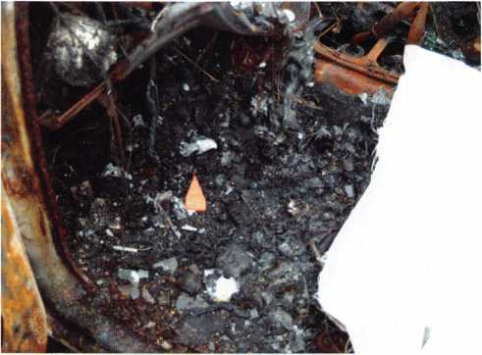

Once the large pieces of debris are cleared the smaller parts can be readily located removing thin layers one at a time

Now the search for parts related to the ignition lock and other vital components starts. Searching through fire debris is analogues to an archaeological dig. The debris is removed in small areas a thin layer at a time. I usually start with removal of the large pieces embedded in the debris first. Things like the remains of the drivers airbag, the upper portion of the steering column, and other larger pieces of debris.

Removal of debris embedded in the debris pile is carefully done by using a small brush and removing all the loose debris around the piece. As I brush away the loose debris I note any parts that might be located in the debris I am removing. I sweep the loose debris into a dustpan and then sift it through a food colander to separate any small springs, screws or other parts I may have missed. I then literally dig the part loose from the debris, removing a little bit of the debris around the part at a time.

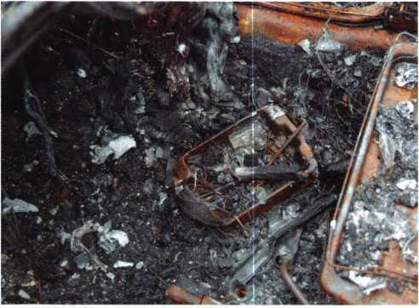

As I loosen the debris I also sift it for small parts. When I have exposed the large piece that it is almost free of the debris I lift it up out of the debris. When this is done debris sticking to the underside of the large piece generally will break loose from the main debris pile. I remove and clean the part over my colander, so any attached debris falls into the colander and can be sifted. I do this with all the larger embedded objects until the debris pile is cleared of all major large pieces of debris.

With large pieces of loose debris removed only debris that fell during the fire remains



Keynotes • April 2006

Once the larger pieces of debris are cleared the removal  
and sifting process begins. During this process the debris  
is scraped away a thin layer at a time using a brush to  
sweep away just the very top layer of the debris. As the  
debris is swept away various parts will be exposed. As each  
part is exposed, mark it and photograph it in place, and  
note the location where it was found and the approximate  
depth (top, middle bottom of debris pile) in the debris  
where it was found. Each sweeping of debris is also sifted  
for small parts you might have missed.

As you remove more and more debris you will continue to

find various parts of the steering column, the electrical

J j . i . . i . _ Ignition lock still embedded in debris

components or the dashboard, and other parts that are not a

part of the ignition lock. Note what parts you found and

where these parts are found in the debris pile.

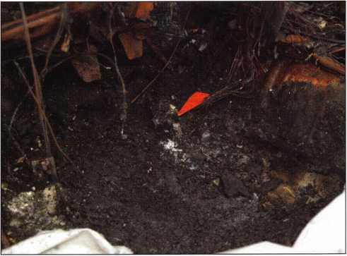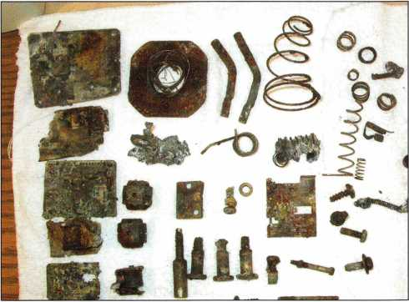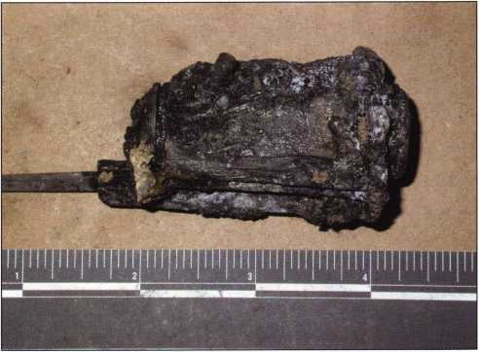

Ignition lock recovered intact from debris

Typical debris, other than ignition lock parts recovered from a burnt vehicle. Debris generallyfound includes, springs, screws, relays, electrical components and a whole host of other items

Continue with the scrape, sweep and sift routine until you  
have reached the floorboards of the vehicle. You might just  
be surprised what you find in a debris pile.

It is very important to note where you find the item in a  
debris pile and at what level you find each item. Certain  
characteristics of a fire are the same for every fire. One is  
heat rises, debris falls and all fires need heat, fuel and oxy-  
gen to burn. Because of these characteristics that the fire  
debris of a vehicle can be analyzed and the location of the  
ignition lock determined at the time of the fire.

Keynotes • April 2006

In a vehicle fire the debris burns and falls to the floor or a lower level in the vehicle. As it falls it continues to burn, as long as it has oxygen to do so. As more debris falls on top of it the burning debris stops burning because it can no longer get any oxygen. It then begins to cool and solid­ify. As more and more items burn and fall to the floor or lower level the debris pile gets deeper and the lower

items stop burning. The items that were burnt first or are already on the floorboards are found on the bottom of the debris pile. The items that fell to the floor last are found on or near the top of the debris pile. This is a concept known as layering.

Layering allows the forensic locksmith to determine the location of the ignition lock at the time of the fire. If it is on the bottom of the pile, under all the debris, it was not in place at the time of the fire and was removed prior to the fire. If it is on top of the debris pile it was one of the last things to fall during the fire and was probably in place on the steering column or dash at the time of the fire. Location of the remains in the debris pile is critical.

As you can see from the process used to analyze the debris in a burnt vehicle the forensic locksmith must possess skills not normally possessed by a general locksmith. The foren­sic locksmith must have a basic knowledge of fires and arson investigations; he must know what the various com­ponents of a steering column look like, not just the com­ponents of a lock; he must have a basic knowledge of pho­tography and he must know certain rules of evidence such as how to collect an item and how to preserve the evidence after he discovers and recovers it.

Forensic locksmith is not a specialty for all locksmiths. Those that do choose to specialize in it find it enjoyable, challenging and it can be very profitable. However, it does require special skills, special equipment and above all con­tinuing education. You have to stay on top of current technology through training.

For more information on auto theft and arson investiga­tions contact Rob Painter at [robol4@aol.com](mailto:robol4@aol.com) or (414) 698-9696 or contact your local chapter of International Association Of Arson Investigators or LAAI at [www.firear- son.com](http://www.firear-son.com).



Keynotes • April 2006

hone in ^

Classic 1956 Thunderbird!

sponsored by:

FKI

SECURITY GROUP

/in) Security & Safety

Vl* * Pram Scarce. Proven Solutions.



SECURITY PRODUCTS

**One Lucky Member Attendee at ALOA 2006 is going home with  
this gorgeous mint-condition 1956 Ford Thunderbird.**

**A ticket will be given to each ALOA Member who registers and attends the  
show. Someone has to win it, and it might as well be YOU!**

**(Must be present to win. Board Members, Exhibitors, Employees,  
Family Members of Employees, and nonmembers are not eligible**

**for this door prize.)**



An Interesting Call

By: T.F. Stern

Yesterday afternoon I had a woman call me asking for prices; nothing strange about that, it happens all the time. I generally like to know who I’m talking to as a social courtesy. It is just plain good business and helps to start things off on the right foot When I asked the caller her name she replied, “The car belongs to my sis­ter; why do you need to know my name?” I use one of those old-fashioned cell phones that doesn’t have a built-in camera so she couldn’t see me shake my head and start to grin as I looked with my eyes rolled upwards.

“Okay” I replied, “can you tell me what I’ll be making a key to?”

“It’s a 1998 Ford Ranger that belonged to my son” she said and continued with a lengthy explanation as to the probability that the keys were in some relative’s pocket because she was too old to be driving and they might have intentionally withheld the keys. “How much will it cost to make a key?”, she asked.

I went on to explain that I would quote her two prices because the particular year model had, on some models, a plain mechanical key and others had a transponder key system for which I would have to charge more.

“I’ll take the cheaper key. We’re trying to save money” she replied. I explained that I couldn’t say for sure which price would be in effect until I had a chance to examine the vehicle, turn the key in the ignition and see if it was equipped with the transponder system. When she hung up I wasn’t sure that she had understood my explaination about the newer key systems and the price difference.

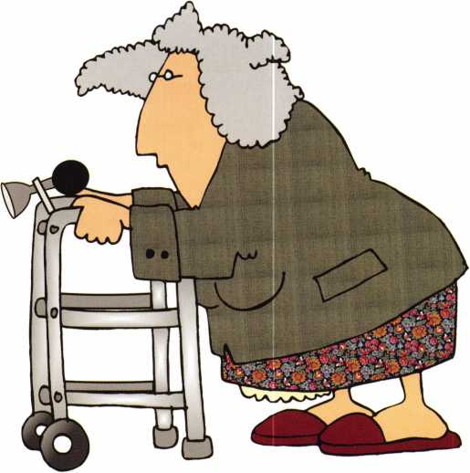

Keynotes • April 2006

This morning, she called back and was still reluctant to tell me her name. “Remember me?” she asked, “I called about my sister’s Ford Ranger? You can come make that cheaper key, now. Shes expecting you.” I went over the price, explaining the same thing as before.

She replied “She cant afford the other key so just make the cheaper key”.

“It was no use. Just do it” I thought.

“Can I get an address and a phone number?” I asked. I then took down the information. I was familiar with the location and it wasn’t far from the job I was finishing. “I can be there within the hour but it would be nice to have her name in case I have to call.”, I said. The woman then gave me all the requested information along with her own phone number, just in case I had to call back.

“Thank you, I’ll be there shortly”, I replied and drove the short distance over. Upon pulling up in front of the house, I called the number to let her know I was one of the “good guys”. I had dialed the back-up phone number by accident and recognized the voice immediately as she answered the phone. “I’m just letting you know I arrived” I said.

I then walked up to the front door. The storm door per­mitted a view of the living room. A very old and feeble woman was charting a course for the front door; one labored and calculated step at a time. On her way, she made sure to catch a piece of an arm chair, a corner of a table and then the next chair until arriving at the front door. I quietly prayed for her safety as it was painfully clear that she should be using a walker or, at the very least, a sturdy cane.

“You’ll forgive my slowness.” she said. “I just got out of the hospital with a broken hip.” I winced at the idea of her walking around at all.

“I have a cane in my truck. Please, let me get it for you.”, I offered. (Sometimes my back will pinch on me while working and so I keep the cane behind the front seat just in case. I’ve only had to use it a couple of times but it’s worth having.)

“No thank you”, she said. “They gave me one of those walker things. I can’t stand it.. .gets in the way all the time.” I could see her trying to figure out how to turn around with hesitation and a look of exasperation on her face as she called out to her housekeeper, “Did you unlock the garage?” I heard the garage door opening and let her know that I could take care of what ever needed to be done and asked her to PLEASE sit and make her self comfortable.

I made the key in short order but the battery on the truck was so weak that I had to jump start it. I keep a set of jumper cables handy for such occasions. The truck started right up with the cheaper key and I figured these people must be living under a “special star”. I backed my truck out of the garage and while I was putting up my tools,

I noticed that the woman had come out into the garage with a few bills folded up in her hand to pay me with.

“I’ll be right there. I’m just making you a spare key. There’s no charge! It’s on the house”, I called out. I then looked over and my stomach began to tighten. She was sprawled out on the floor. How she fell, I have no idea. She hadn’t cried out in pain. In fact, she had a silly grin on her face, still holding the rolled up bills up as if to pay me.

“Please! Somebody going past will think I’m robbing you”

I said as I forced a laugh and went to help her up. I was praying that she hadn’t broken an ankle, her hip again, or something else.

“I’m fine!” she replied, “I just tripped over that piece of wood. Really, I’m okay.” I walked her back inside the house and accepted her payment. She wanted me to stay around and charge the battery, move the truck out of the garage and some other things.

I told here that I was sorry but I had another customer waiting on me. I needed to go but I was thinking to myself, “Please, God, let her live until I’m out of the driveway!” knowing that her house keeper was there to tend to things.

Keynotes • April 2006

**21**

SAFETECH 2006

Safe Technicians Gathered in Albuquerque, NM for the Premier Industry Event

Attendees arrived from around the globe to learn tech­niques only available at Safetech 2006. Set amid a back­drop of the beautiful Southwestern United States, SAVTA members battled travel and altitude changes to increase their earning potential and learn from the best instructors in the realm of physical security.

CLASSES

Classes were exciting and varied and attendees appreciated and enjoyed the many networking and social events pro­vided. One of the most-popular classes at SAFETECH was GSA from A-Z. Here, students learned about GSA- approved containers from Department of Defense safe man, Vaughan Armstrong.

Instructor Vaughan Armstrong said to his class, “I have been to SAFETECH every year since it started because it is the best place to share information about the industry.”

Professional Safe Opening is a class taught by professional safe technicians, Ron Jewell and Ken Hiemstra. Heavy with hands-on instruction, this class was a SAFETECH favorite among attendees.

Instructors Hiemstra and Jewell taught in tandem using carefully-timed humor and clever wit to illustrate their les­sons. Offering expert guidance in safe-opening techniques, drill points, relock defeat, safe construction, locks and tools, Hiemstra and Jewell made it their goal to work closely with students.

Jewell and Hiemstra wanted students to learn to “think on their feet” so safes were set up to create the maximum chal­lenge. Since the real-world doesn’t offer easy openings, nei­ther do these two instructors. The goal for students is for them to “kill the safe with one hole” using methods

learned in the class. When asked by a student for hints on opening one of the class safes, Jewell quipped, “The safe is downstairs.”

Students worked in groups to meet the challenge. They soon found that the skills of each group member could be used to quickly and efficiently defeat the safe.

Another poular class was Professional Safe Opening taught by personable instructor, Jim Jeffries. Heavy with hands-on instruction, this class was not only informative, but FUN!

Jeffries’ offered students a systematic approach to properly servicing a safe lock, along with practical business advice to increase profits. In this class, students found practical tips and tricks used by serious professionals.

Offering expert guidance in dialing, instead of drilling safe locks. Jeffries worked closely with students, entertaining them with industry humor and sly wit.

A hands-on class, students enjoyed learning from doing as they experienced problems they might find in the real world.

Students said they were looking forward to implementing new ideas learned at SAFETECH to boost their bottom line.

EVENTS

One of the most-popular events at SAFETECH is the Bazaar Night/Swap Meet. SAVTA provided the set up and attendees provided the items to sell or trade. Attendees got together with friends for a fun-filled evening overflowing with great deals. They brought most anything: books, tools, drill bits, photos, old locks, technical information, lock parts, etc. because “One man’s trash is another man’s treasure.”

The Kick-off Party provided a great atmosphere to mix and mingle with suppliers and colleagues. Guests enjoyed

**22**

Keynotes • April 2006

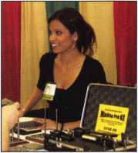

Keynotes • April 2006

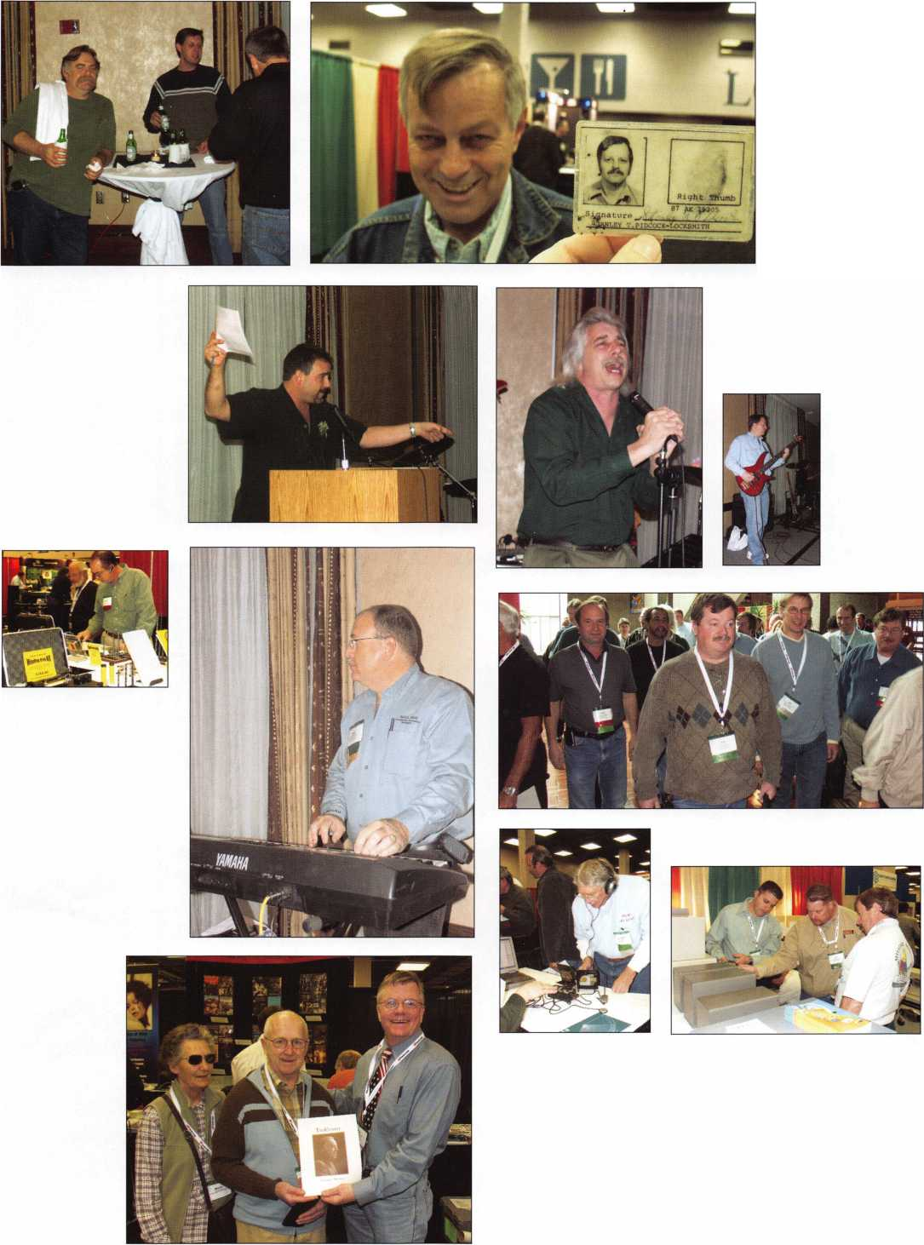

|  |  |
| --- | --- |
|  |  |
|  |  |
|  |  |
|  |  |
|  |  |
| * - - - ~ | |
|  |  |
|  |  |
|  |  |
|  |  |

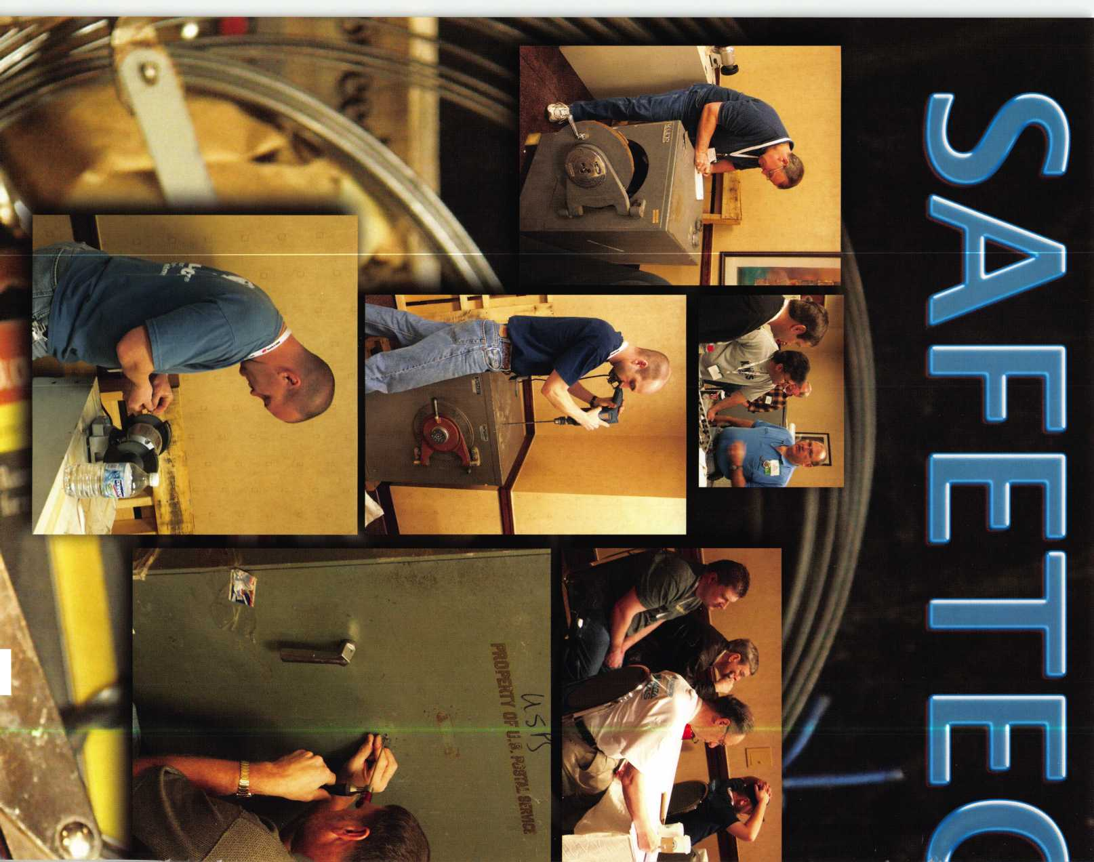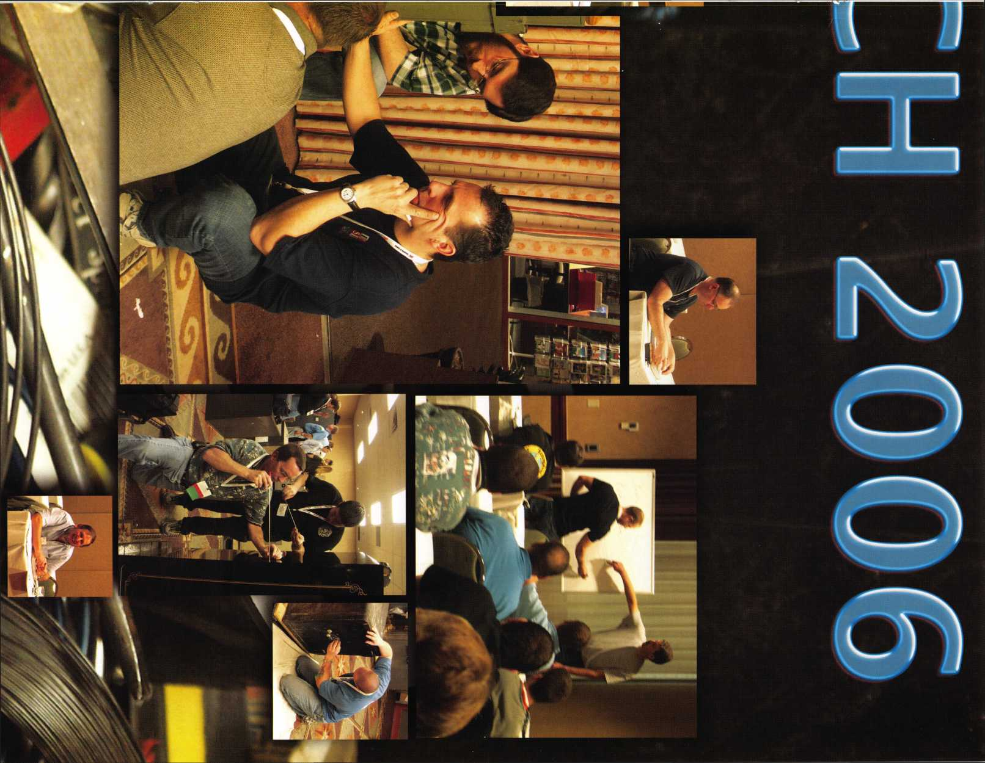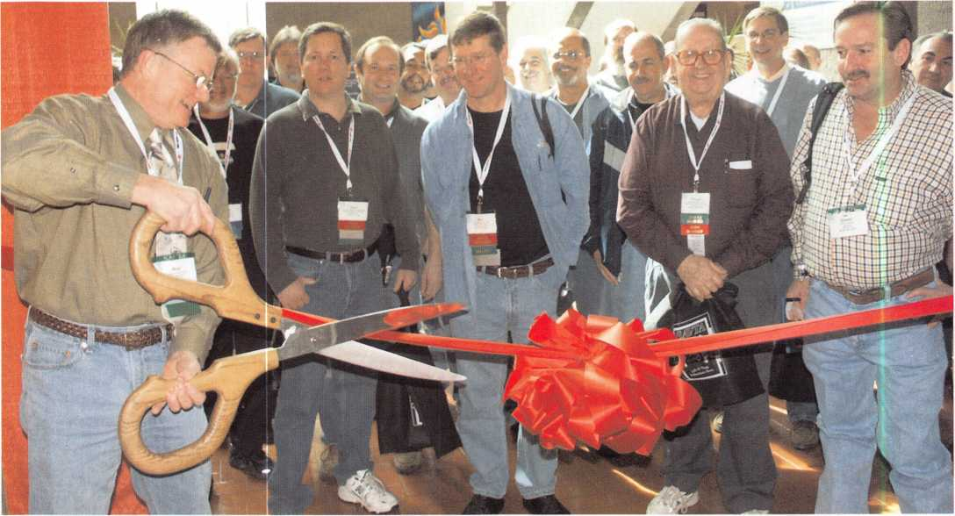

a fiesta-themed menu.  
After dinner, the Friends  
of SAVTA Auction  
began. Lockmasters’  
Mark Miller was a  
dynamic and energetic  
host, helping to raise  
$20,280.00 auctioning  
locks and specialty items  
including some hand-  
crafted by SAVTA Hall-  
of-Fame inductee,  
Tommy Watson. One

bidding war after another sent attendees home with an  
Albuquerque hot-air ballon ride for two and other fun  
items like lunch with SAVTA Sales Manager, Kim  
Hammond and dinner with LaGard representatives.

The evening ended with a bang when some talented SAVTA musicians took the stage. Bob DeWeese wailed on the mic to traditional rock favorites such as “Proud Mary”, whipping the SAVTA crowd into a frenzy of dancing and good times. Bill Smith’s dance card was full as he whirled the ladies across the floor.

Special thanks to our friends at LaGard and Lockmasters  
for sponsoring the event

ISLAJGARD

**locwnasnus**

INCORPORATED

EXHIBITS

Exhibitors brought and  
displayed the most up-  
to-date equipment in the  
industryat at the  
SAFETECH 2006 Trade  
Show. Members agreed it  
was the perfect place to  
view new products, tools  
and equipment and meet  
with industry experts one  
on one.

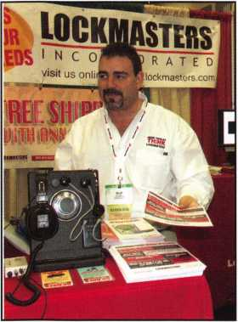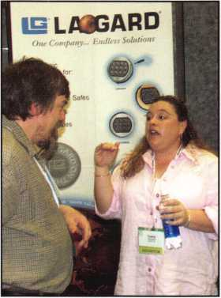

Keynotes • April 2006

**Security Products**

**A Division of The Eastern Company**

**301 West Hintz Road Wheeling, IL 60090 Telephone: 800.733.8588 Fax: 847.537.1881 [www.cclsecurity.com](http://www.cclsecurity.com)**

Features & Benefits

Industrial Strength Combination Lock! Resists Hammer and Re-bar Attacks! Hardened Steel Full Metal Jacket!

Hardened Steel Full Metal Jacket Shroud! Weather Resistant Black Electrocoating! 7/16” Chrome Plated Molybdenum Shackle! Inside Shackle Clearances: 1” and 2”! Shackle Pull Strength: 2,750 pounds!

All Brass Inner Mechanism!

Four All Brass Dials!

10,000 Changeable Combinations!

Quick Delivery: Shipped from Stock!

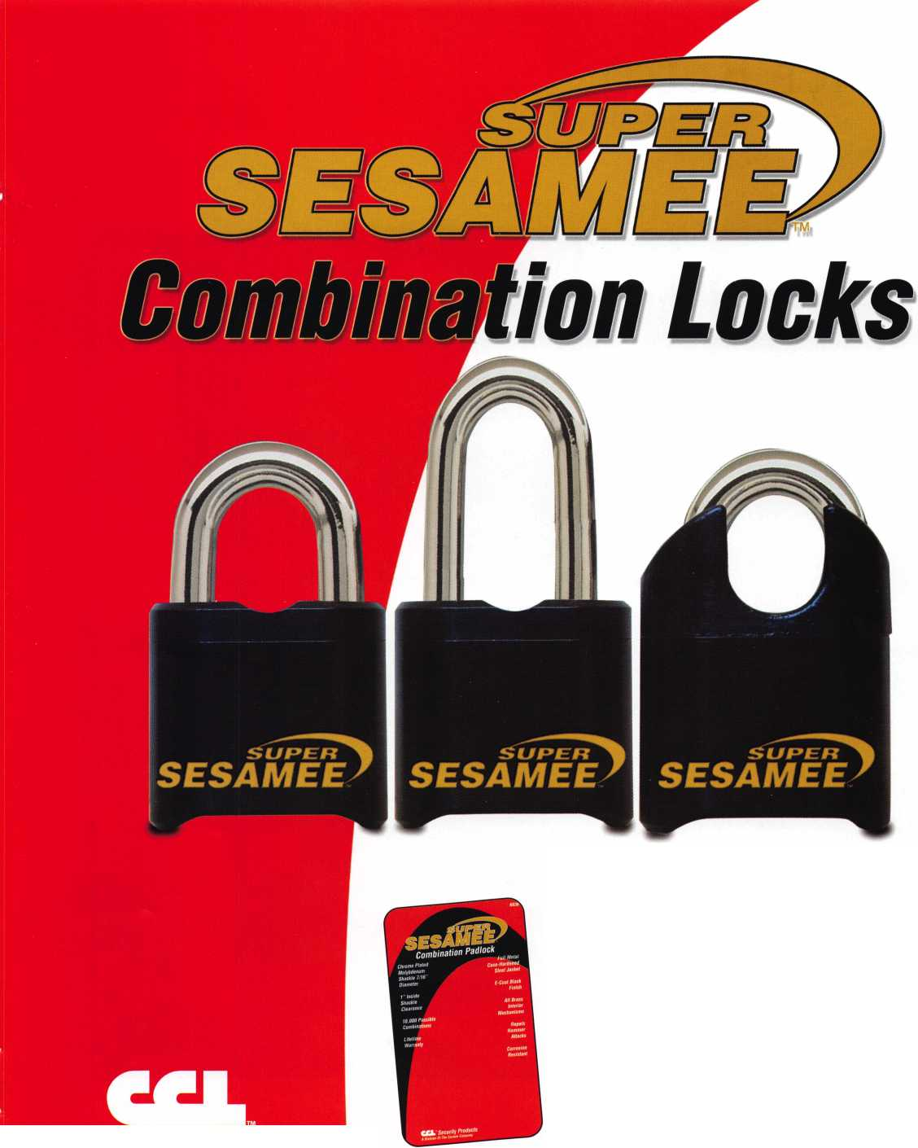

Mosler Retro

by Greg Perry, CML, CPS

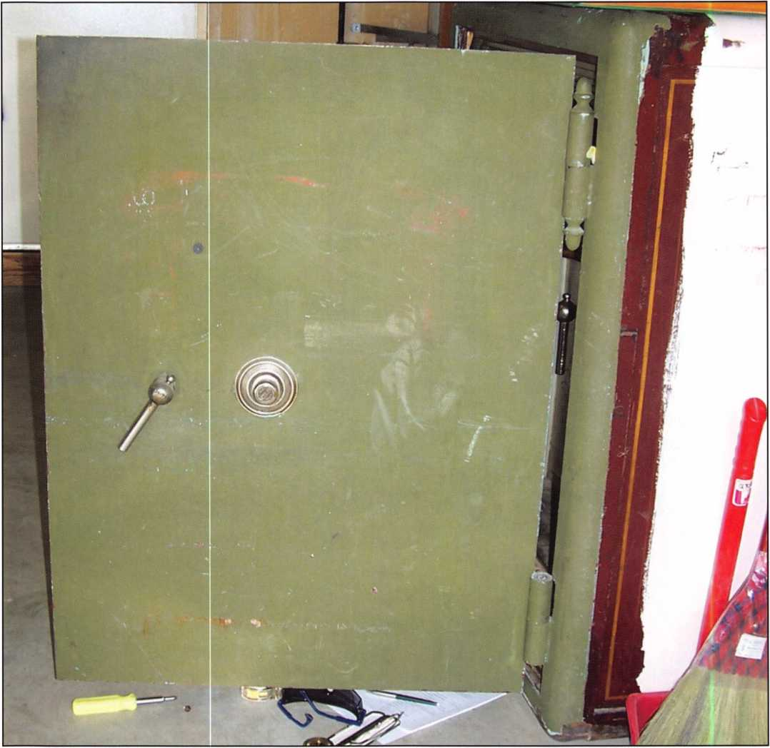

Photo 1

Keynotes • April 2006

This months safe started with a cus-  
tomer who needed the interior jewel-  
ers chest of a Molser heavy wall cast  
iron safe opened so he could retrieve  
the contents and throw away the  
safe. The lock had stopped working  
after he took a pair of locking pliers  
to the dial because it was too hard to  
turn by hand. He wanted a new gun  
safe and this was a good excuse to  
purchase a new one.

Since he didn’t want the safe, I  
removed the locks and the interior  
door after opening it. (Can you  
guess why I did this? Look in the  
May 2005 Keynotes for the full story  
on a jewelers chest.)

Later, the customer called to say that  
he noticed that, with the interior  
door removed, access to the interior  
was improved. He asked how much  
it would cost to install a new lock as  
he wondered if the safe was worth  
keeping after all.

Most customers who want to retrofit  
a new lock opt for an electronic lock.  
Although electronic locks have come  
a long way with regard to reliability,

I doubt any of them will last the  
100-plus years this safe’s original  
lock had lasted. This customer want-  
ed long life.

He also wanted an external relock  
installed. The lock looked simple to  
install, but the relock might be a lit-  
tle bit more of an issue.

A side note: at first glance, this  
retrofit might have been much easier  
with a LaGard SwingBolt type lock.  
The biggest advantage to the  
SwingBolt is the ability to mount the  
lock anywhere inside the safe the  
cable will reach. It does not need a  
mechanical connection to the out-

Photo 2

Photo 3

Photo 4



Keynotes • April 2006

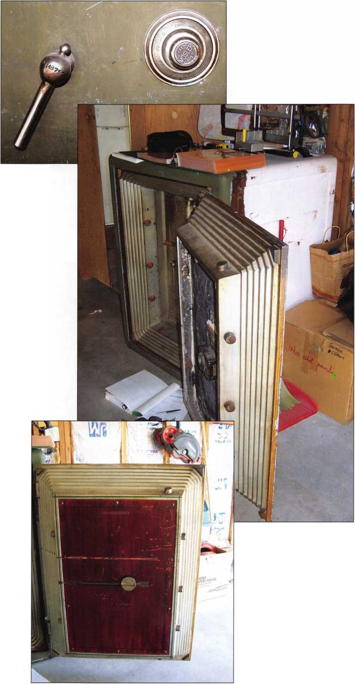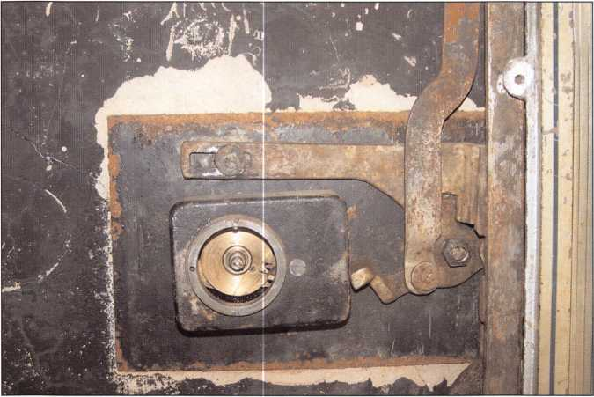

Photo 5

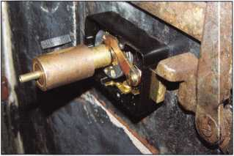

Photo 6

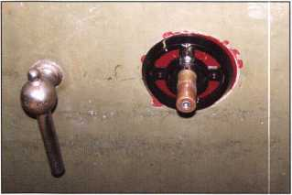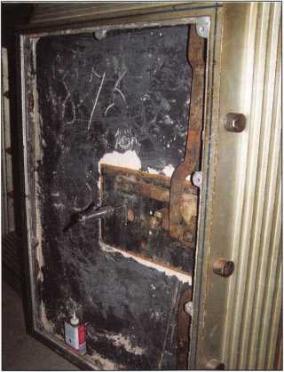

Photo 7

Photo 8

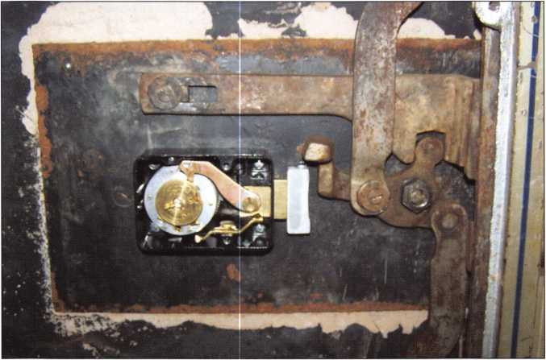

Photo 9

side. The only connection from the key­pad is a wire. The lock case could have been mounted without an extension at the end of the handle cam. The reason it would not have worked is because of the handle cam. If it travels past the end of the bolt, the SwingBolt extends and the boltwork could not be extended. A mod­ification to the handle cam might have worked to solve this problem.

Starting with the lock required making a bolt extension. The original Molser 5H lock is much larger and has a bolt that is 1 5/8” tall, as opposed to the S&G 6730 bolt that is 1 ” wide. A block of alu­minum was machined 1/2” x 1/2” x 1 5/8” and a couple of mounting screw holes were drilled to attach to the end of the 6730 bolt. The Mosler lock mounted to a tube assembly and had 4 standoffs to move the lock body away from the door. Once the tube was removed the S&G lock sat flat against the inner surface. At the safe, a DRAT tool was used to align the dial ring and lock case on the door. This allowed for a transfer punch to mark the four lock body mounting hole loca­tions. These were drilled and tapped for the 1/4” 20 thread screws. The lock bolt extension was placed in the approximate location of the original lock and marked. It was a little long. Part of the problem was the handle cam. It was tapered slight­ly (front to back) and it bound against the extension as it turned. This was aggravated by the lock location. It was mounted to the inside face, instead of on standoffs like the original lock. Instead of changing the lock bolt or mounting, a curve was sanded into the end of the bolt extension. Although not needed, a steel screw was added to the top of the bolt extension to remove the gap between the handle cam and the lock bolt. Finally, the dial ring screw locations were drilled and tapped allowing the lock to be assembled.

Keynotes • April 2006

Pick the Best!

The Associated Locksmiths of America Offers You Invaluable Resources

ALOA is excited about the things planned for 2006. To celebrate our 50th anniversary this membership campaign features more benefits than ever.

* Education Discounts
* Automatic Entry into a drawing for a Key Machine
* Up to $300.00 savings on ALOA 2006 Anniversary convention registration.

ALOA Gives YOU:

Industry News and Information  
Publications and Public Relations

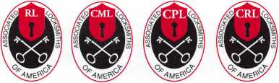

Professional Certification

* A free $10,000.00 bond (Active members only)
* New members receive immediate access to thou­sands of keycodes with a free trial membership to Blackhawk Products.
* ALOA store with books & merchandise
* A 10% discount for any bookstore purchase
* Celebrating 50 years in the security industry
* Referral Service

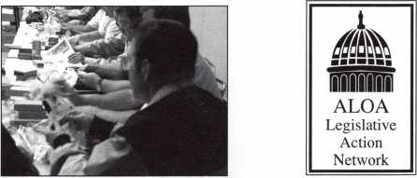

Educational Training Programs Representation to the

Industry and Government

ALOA’s Convention and Trade Show

• Professional Publication - Keynotes

ALOA offers you the strength of over 8,000 leading firms and individuals. We are able to open many doors leading to the recognition, information, productivity and perspective needed for success in our ever-changing industry.

ALOA is your voice in the industry. It speaks for your concerns, your needs and your strengths. ALOA represents the collective interests of the association before the press, government, and the public.

1956-2006

ofNIany

The ALOA Convention and Security Expo, held annually, is an important event for locksmiths, manufacturers, and distributors. Here, you can learn from professional speakers, discuss needs with suppliers and seek solutions with fellow members and participants.

***Come celebrate SO years of Excellence at the ALOA 2006 Convention & Security Expo in fabulous Las Vegas, NV, July 8-16.***

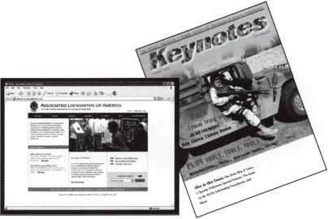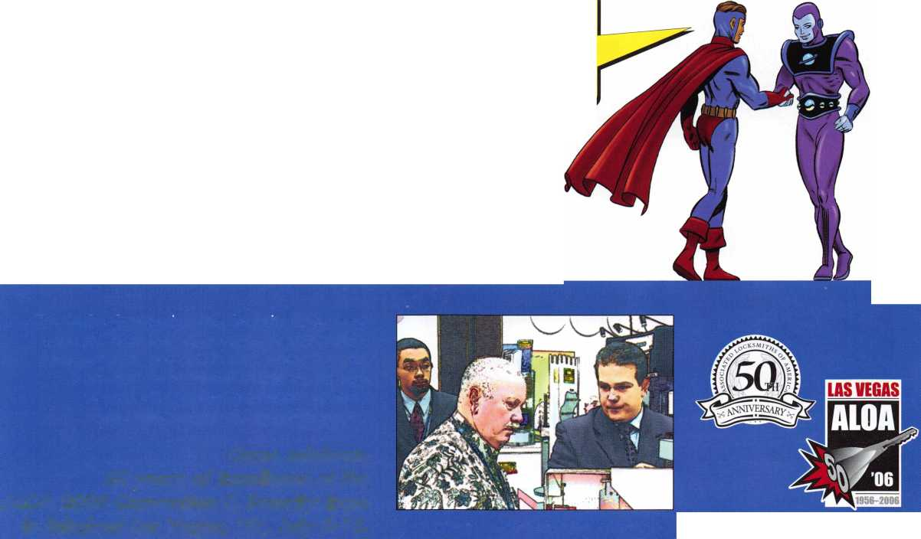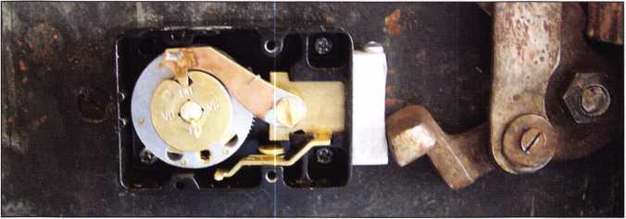

Photo 10

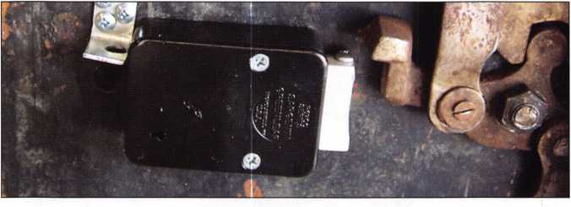

Photo 11

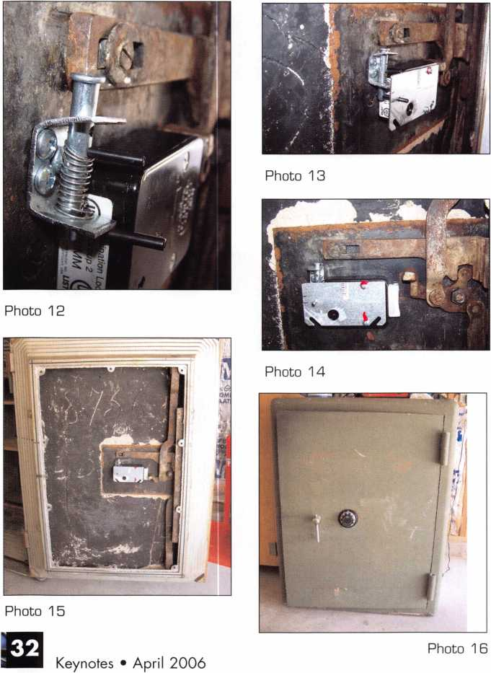

The relock assembly turned out a little  
different than originally planned. I  
toyed with the idea of using a wire  
attached to a spring loaded bolt to  
block the vertical bar. I finally decided  
on the KISS (Keep It Simple Stupid)  
method. The plan was to use a modi-  
fied bolt to fire behind the boltwork  
linkage.

Looking around the hardware store I  
found “universal clevis pins”. Instead  
of having just one hole at the end they  
have a series of holes along the length.  
Next, a blank 4S metal electrical cover  
plate was cut, bent and drilled to  
accommodate the clevis pin. It needed  
to be tight against the lock body since  
the end of the boltwork and lock body  
were in the same vertical plane.

The last hole and a middle hole on the  
clevis pin were drilled to accommodate  
roll pins. Finally, a spring was added  
between the bottom fold on the brack-  
et and one of the roll pins to fire the  
relock.

There is one modification I would  
make in the future. Drill the roll pin  
holes at 90 degree angles to allow the  
one next to the spring to be installed  
sticking out on both sides of the clevis  
pin. No, its not a new design but it’s  
the first time I’ve had to make one  
from scratch. The balance of the  
electrical cover was used to make the  
bracket to hold the relock in the  
cocked position.

From start to finish, this retrofit took  
about five hours (not including the  
time spent thinking about how I want-  
ed to create the relock). I really didn’t  
run into any difficult challenges on  
this job. I could have wished for a  
better or trickier method to install the  
relock but in the end this one does the  
job. I took good pictures and dimen-  
sions for the relock location because if  
something does happen and the lock is  
punched it might baffle another tech.

**TrueCenter**

the Harry C. Miller story

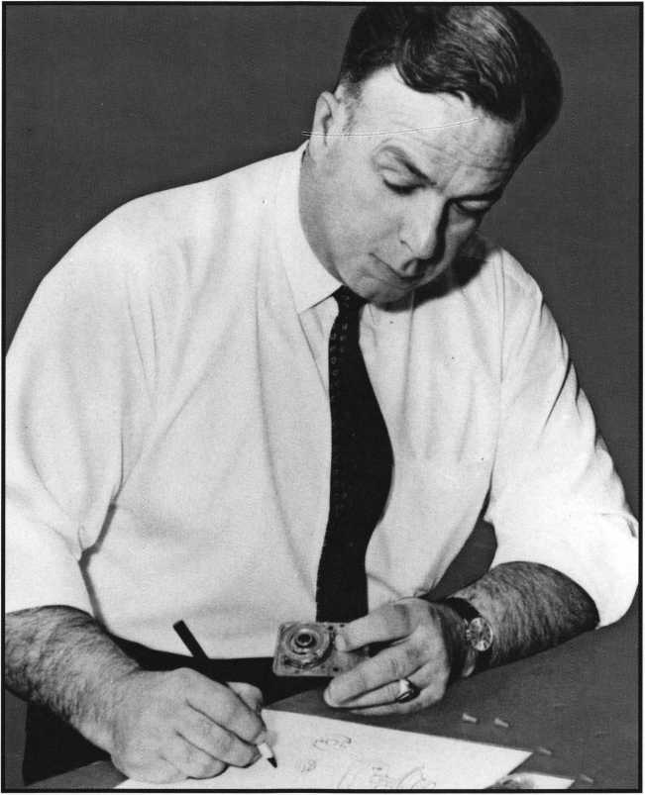

AVAILABLE NOW AT THE  
ALOA BOOKSTORE!  
PURCHASE YOURS ONLINE TODAY!

[www.aloa.org/](http://www.aloa.org/) store

■HP

a fresh hew look

new message boards

download prp info for specific sittings

choose your own password to the \:

member! only section

improvejd locksmith search at . ,

find alocjksmitllaom.



SERVICE

With proper ID and security clearance

we can get codes for most cars.

Fax us at 1 -800-695-6810  
or call 1 -800-741 -4764  
for more information.

Hello, I'm Doug Jameson of Jameson Code Services. We would like to try and make your  
business just a little easier when you make a key. We can furnish a key code to you for  
almost all cars. There is no charge should the code we provide not work. We can have most  
codes back to you within 30 minutes. Some codes are even quicker such as Ford and  
Toyota. We furnish a pin number for Chryslers, also brake codes and immobolizer codes  
for Hondas and Acuras. We have been in the key code business since 1995 and learn a lit-  
tle more everyday. We are open Monday thru Friday 8:30 a.m. to 6:00 p.m. If you have a  
real emergency after these hours or on the weekend my pager number is 972-319-8782.  
There are a few brands I can get a code for after hours. All codes are $15.00. This includes  
a vat number if needed. The $15.00 also includes the pin number, brake code and  
immobolizer code. Corvettes are a special category as the vat numbers are not often avail-  
able. We would appreciate your input and welcome suggestions for improving our service.  
Give us a call at 214-630-0477 to set up your account or to have any questions answered.  
Looking forward to servicing all locksmiths. Fords and Chryslers within 15 minutes!

We are accepting applications from ALOA Members only.

Fax US at 1-800-695-6810  
01 call 1-800-741-4764

**Classifieds**

!

EMPLOYMENT

WANTED

BVI, Inc., a Red Hawk Industries Company is seek­ing several exp. F/T Field Service Techs in MD, DC and VA. Must be exp. in physical and electronic security systems, or gen. bank equipment. Must have 3 + years exp. clean driv­ing record, and pass a drug test. Excellent comp, and benefits pkg. inch com­pany vehicle. Forward resume with salary history to: [Resumes.PA@redhawkin- dustries.com](mailto:Resumes.PA@redhawkin-dustries.com) or fax to Linda Foggie at 215-396-8799.

STORE MANAGER WANTED

Opportunity in South Orange County, California for person with extensive locksmith and/or distributor experience. Position pro­vides salary, helath insur­

ance, vacation and holi­days. Send resume to: 949-492-0246 or call Tony's Locksmith at 949- 492-5731.

LOCKSMITH WANTED

$3670.8144461.90 per month. The City of Chula Vista (San Diego's County second largest city) is cur­rently seeking to fill their Locksmith position that will plan, implement and maini- tain a master lock and key program including comput­er based acccess control systems throughout the city buildings. This position has full benefits and will receive 1 6% COLA increase over the next four years. City of ChulaVista, 276 4th Ave, Ca. 91910 [www.chulavis- taca.gov](http://www.chulavis-taca.gov) or 619-691-5096 for more info. Apply imme­diately!

WANTED TO BUY/SELL

NEW LOCKSMITH SHOP FOR SALE

Leased store front shop. Would like to retire due to health. Next to NASA Bay Space Center, on a very busy highway. Covering three counties. Over $70,000 plus in equipment and inventory. Fully equipped van. Asking $55,000, will consider all reasonable offers. Email if interested

[www.fgarza](http://www.fgarza) [1948@yahoo.com](mailto:1948@yahoo.com) or fax 281-488-0883.

BUSINESS FOR SALE Ideal business for 1 person or easily expand business. Established 1 997 - mostly commercial and residential. Repeat and referral busi­ness with $0 paid advertis­ing, close proximity accounts (about 8K miles per year), bankers hours

(M-F 9-5, Sat 9-3). Shop equipment, tools and inven­tory, 2003 truck (less than 50K miles) with equipment, tools, and inventory. Deal on shop lease if desired or run as a mobile business. Asking $150K - annual gross sales over 100K - annual net profit well over 50K. Located in Houston, TX. Call Ron 281-660- 3000.

BUSINESS FOR SALE

Turn key lock shop busi­ness, over 20 years same location. In the most enchanting and diverse region on Earth. Port Angeles, Wa. where the Olympic Mountains meet the Sea. $170,000 Includes all equipment, inventory, tools, customer list and training. Call Harriet at Windermere Real Estate 1-800-786- 1456 ext. 30

BUSINESS FOR SALE

In south-central Wisconsin, well-established, 19 years in the same location. One per­son shop with room to expand.Business has many commercial and residential accounts. Includes service van,equipment,and invento- ry.$85,000 takes all.

Owner wishes to retire-will help with transition. CALL (608)325-5011 OR EMAIL: [lockshop@tds.net](mailto:lockshop@tds.net)

SMALL MOBILE LOCKSMITH BUSINESS FOR SALE

Established 1979 with solid client base. Excellent oppor­tunity for someone who is wanting to relocate and start a business. Located in sunny Albuquerque, NM. We're ready to retire!!! Commercial Safe & Lock 475-58th St. NW Albuquerque, NM 87105 505-836-9503

FOR SALE

Locksmith equipment and inventory. Machines, keys, locks, tools - all for one low price - due to health, must sell. ALOA member. Forest E. Long, 970-854-3301

WANTED TO BUY

Want to purchase old and discountinued Schlage Decorative Hardware in both Dragon and La Fontaine designs. Any assistance would be gladly welcome. ALOA member. Peter Field, P.O. Box 104, Salem, VA, 24153. Tel. 540-380-5000. Fax. 540- 380-1657.

Classified Advertising Policy

Classified advertising space is provided free of charge to ALOA members and for a fee of $2.00 per word, $40.00 minimum for non members. Classified ads may be used to advertise used merchandise and overstocked items for sale, "wanted to buy" items, business opportunities, employment opportunities/positions wanted and the like. Members or non members wishing to advertise services or new merchandise for sale may purchase a "Commercial Classified Ad" for a fee of $4.00 per word with a minimum of $100.00. Each ad will run for two issues. For blind boxes there is a $10.00 charge for members and non members. All ads must be submitted in writing to the Advertising Sales Department via fax at 817-645-7599 or through an email to [adsales@aloa.org](mailto:adsales@aloa.org) by the fifteenth of the month two months prior to issue date. ALOA reserves the right to refuse any classified adver­tisement that it deems inappropriate according to the stated purpose of the classified advertising section.



Distributor

**1st In Hardware, Inc.**

Phone: Phone: 410-646-9900 Fax: 410-646-0045 www. 1 stinhardware.com

**ADEL Fingerprint Technology, LLC**

Phone: 909-595-1222 Fax: 909-595-1667

**Accredited Lock Supply Co.**

Phone: 800-652-2835 Fax: 201-865-2435 [www.acclock.com](http://www.acclock.com)

**Andrews Wholesale Lock Supply**

Phone: 717-272-7422 Fax: 717-274-8659 [www.andrewslock.com](http://www.andrewslock.com)

**Boyle & Chase Inc.**

Phone: 800-325-2530 Fax: 800-205-3500 [www.boyleandchase.com](http://www.boyleandchase.com)

**Clark Security Products**

Phone: 888-784-1311 Fax: 619-718-7333 [www.clarksecurity.com](http://www.clarksecurity.com)

**Cook's Building Specialties**

Phone: 505-883-5701 Fax: 505-883-5704

**Dire's Lock & Key Company**

Phone: 303-294-0176 Fax: 303-294-0198

**Direct Security Supply, Inc.**

Phone: 800-252-5757 Fax: 800-452-8600

**Discount Key Machines.Com/Busch**

Phone: 800-332-8724 Fax: 407-363-4666

**Doyle Security Products**

Phone: 800-333-6953 Fax: 612-521-0166 [www.doylesecurity.com](http://www.doylesecurity.com)

**Dugmore and Duncan, Inc.**

Phone: 888-384-6673 Fax: 888-329-3846

**E. L. Reinhardt Co., Inc.**

Phone: 800-328-1311 Fax: 651-481-0166 [www.elreinhardt.com](http://www.elreinhardt.com)

**Ewert Wholesale Hardware**

Phone: 800-451-0200 Fax: 708-597-0881

**Foley-Belsaw Company**

Phone: 800-821-3452 Fax: 816-483-5010 [www.foley-belsaw.com](http://www.foley-belsaw.com)

**Fried Brothers Inc.**

Phone: 800-523-2924 Fax: 215-592-1255 [www.fbisecurity.com](http://www.fbisecurity.com)

**H.L. Flake Co.**

Phone: 800-231-4105 Fax: 713-926-3399 [www.hlflake.com](http://www.hlflake.com)

**Hans Johnsen Company**

Phone: 214-879-1550 Fax: 214-879-1530 [www.hjc.com](http://www.hjc.com)

**Hardware Agencies, Ltd.**

Phone: 416-462-1921 Fax: 416-462-1922 [www.hardwareagencies.com](http://www.hardwareagencies.com)

**IDN Incorporated**

Phone: 817-421-5470 Fax: 817-421-5468 [www.idn-inc.com](http://www.idn-inc.com)

**Instant Hardware Delivery, Inc**

Phone: 800-355-1 107 Fax: 800-663-8518

**Intermountain Lock & Supply**

Phone: 800-453-5386 Fax: 801-485-7205 [www.intermountainlock.com](http://www.intermountainlock.com)

**International Electronics, Inc**

Phone: 800-343-9502 Fax: 617-821-4443

**Jo Van Distributors**

Phone: 416-288-6306 Fax: 416-752-8371 [www.jovanlock.com](http://www.jovanlock.com)

**Lockmasters, Inc.**

Phone: 859-885-6041 Fax: 859-885-7093 [www.lockmasters.com](http://www.lockmasters.com)

**Locks Company**

Phone: 800-288-0801 Fax: 305-949-3619

**Locksmith Ledger International**

Phone: 847-454-2700 Fax: 847-454-2759 [www.lledger.com](http://www.lledger.com)

**McDonald Dash Locksmith Supply**

Phone: 800-238-7541 Fax: 901-366-0005 [www.mcdonalddash.com](http://www.mcdonalddash.com)

**Monaco Lock Co.**

Phone: 800-526-6094 Fax: 800-845-5625 [www.monacolock.com](http://www.monacolock.com)

**Omaha Wholesale Hardware**

Phone: 800-238-4566 Fax: 402-444-1664 [www.omahawh.com](http://www.omahawh.com)

**Phoenix Safe International LLC**

Phone: 765-483-0954 Fax: 765-483-0962 [www.phoenixsafeusa.com](http://www.phoenixsafeusa.com)

**Positive Identity Solutions**

Phone: 704-663-1 175 Fax: 704-660-1301 [www.pids-usa.com](http://www.pids-usa.com)

**RA-Lock Company**

Phone: 972-775-6301 Fax: 972-775-6316 [www.ralock.com](http://www.ralock.com)

**Security Distributors Inc**

Phone: 800-333-6953 Fax: 612-524-0166

**Security House**

Phone: 905-669-5300 Fax: 905-660-6313 [www.securityhouselock.com](http://www.securityhouselock.com)

**Security Lock Distributors**

Phone: 800-847-5625

Fax: 800-878-6400

[www.securitylockdistributors.com](http://www.securitylockdistributors.com)

**Southern Lock and Supply Co.**

Phone: 727-541-5536 Fax: 727-544-8278 [www.southernlock.com](http://www.southernlock.com)

**Stone & Berg Wholesale**

Phone: 800-225-7405 Fax: 800-535-5625

**The Locksmith Store Inc.**

Phone: 847-364-51 1 1 Fax: 847-364-5125 [www.locksmithstore.com](http://www.locksmithstore.com)

**Timemaster Inc.**

Phone: 859-259-1878 Fax: 859-255-0298 [www.time-master.com](http://www.time-master.com)

**Top Notch Distributors, Inc.**

Phone: 800-233-4210 Fax: 800-854-4146 [www.topnotch.bz](http://www.topnotch.bz)

**Turn 10 Wholesale**

Phone: 800-848-9790 Fax: 800-391-4553

**U.S. Lock Corp.**

Phone: 800-925-5000 Fax: 800-338-5625 [www.uslock.com](http://www.uslock.com)

**Wilson Safe Company**

Phone: 215-492-7100 Fax: 215-492-7104 [www.wilsonsafe.com](http://www.wilsonsafe.com)

Manufacturer

**A & B Safe Corporation**

Phone: 800-253-1267 Fax: 856-863-1208 [www.a-bsafecorp.com](http://www.a-bsafecorp.com)

**ABUS Lock Company**

Phone: 800-352-2287 Fax: 602-516-9934 [www.abus.com](http://www.abus.com)

**Access Security Products Ltd.**

Phone: 905-337-7874 Fax: 905-337-7873

[www.access-safe.com](http://www.access-safe.com)

**Adams Rite Mfg Company**

Phone: 800-872-3267 Fax: 800-232-7329 [www.adamsrite.com](http://www.adamsrite.com)

**Adesco Safe Mfg. Company**

Phone: 800-694-9340 Fax: 562-408-6427 [www.adesco.com](http://www.adesco.com)

**Adrian Steel Company**

Phone: 800-677-2726 Fax: 517-265-5834 [www.adriansteel.com](http://www.adriansteel.com)

**Advanced Diagnostics USA Inc**

Phone: 650-876-2020 Fax: 650-876-2022 [www.ad-mvp.com](http://www.ad-mvp.com)

**All Five Tool Company, Inc.**

Phone: 860-583-1691 Fax: 860-583-4516 [www.all5tool.com](http://www.all5tool.com)

**American Security Products**

Phone: 909-685-9680x2013 Fax: 909-685-9685

[www.amsecusa.com](http://www.amsecusa.com)

**BWD Locke raft**

Phone: 973-728-3707 Fax: 973-728-3731 [www.bwdautomotive.com](http://www.bwdautomotive.com)

**Bianchi USA, Inc.**

Phone: 800-891-2118 Fax: 216-803-0202 [www.bianchi](http://www.bianchi) 1770usa.com

**Buddy Products**

Phone: 312-733-6400 Fax: 312-733-8356 [www.buddyproducts.com](http://www.buddyproducts.com)

Keynotes • April 2006



**CCL Security Products**

Phone: 800-733-8588 Fax: 847-537-1800 [www.cclsecurity.com](http://www.cclsecurity.com)

**CompX Security Products**

Phone: 864-297-6655 Fax: 864-297-9987 [www.compxnet.com](http://www.compxnet.com)

**D&D Technologies (USA), Inc.**

Phone: 714-677-1300x292 Fax: 714-677-1299 [www.ddtechusa.com](http://www.ddtechusa.com)

**DETEX Corp.**

Phone: 800-729-3839 Fax: 830-620-6711 [www.detex.com](http://www.detex.com)

**Don-Jo Manufacturing, Inc.**

Phone: 978-422-3377 Fax: 978-422-3467 [www.don-jo.com](http://www.don-jo.com)

**Door Controls International**

Phone: 800-742-3634 Fax: 800-742-0410 [www.doorcontrols.com](http://www.doorcontrols.com)

**Doorking Inc.**

Phone: 800-826-7493 Fax: 310-641-1586 [www.doorking.com](http://www.doorking.com)

**FireKing Security Products**

Phone: 800-457-2424 Fax: 800-896-6606 [www.fkisecuritygroup.com](http://www.fkisecuritygroup.com)

**Framon Manufacturing Company Inc.**

Phone: 989-354-5623 Fax: 989-354-4238 [www.framon.com](http://www.framon.com)

**HY-KO Products Co.**

Phone: 330-467-7446 Fax: 330-467-7442

**Hammerhead Industries, Inc.**

Phone: 805-658-9922 Fax: 805-658-8833 [www.gearkeeper.com](http://www.gearkeeper.com)

**Ingersoll Rand Security Technologies**

Phone: 317-805-5713 Fax: 317-805-5779 [www.schlagelock.com](http://www.schlagelock.com)

**Jackson Corporation**

Phone: 323-269-81 1 1 Fax: 800-888-6855 [www.jacksonexit.com](http://www.jacksonexit.com)

**Jet Hardware Mfg., Co.**

Phone: 718-257-9600 Fax: 718-257-0973 [www.jetkeys.com](http://www.jetkeys.com)

**KABA ILCO Corp.**

Phone: 252-446-3321 Fax: 252-446-4702 [www.kaba-ilco.com](http://www.kaba-ilco.com)

**KEY-BAK/West Coast Chain Mfg.**

Phone: 909-923-7800 Fax: 909-923-0024 [www.keybak.com](http://www.keybak.com)

**Keri Systems Inc.**

Phone: 408-451-2520 Fax: 408-441-0309 [www.kerisys.com](http://www.kerisys.com)

**Knaack Manufacturing Co.**

Phone: 800-456-7865 Fax: 815-459-9097 [www.weatherguard.com](http://www.weatherguard.com)

**Kustom Key Inc.**

Phone: 800-537-5397 Fax: 800-235-4728 [www.kustomkey.com](http://www.kustomkey.com)

**LAB Security**

Phone: 800-243-8242 Fax: 860-583-7838 [www.labpins.com](http://www.labpins.com)

**La Gard Inc.**

Phone: 310-325-5670 Fax: 310-325-5615 [www.lagard.com](http://www.lagard.com)

**Lock America, Inc. dba L.A.I. Group**

Phone: 714-373-2993 Fax: 714-373-2998 [www.laigroup.com](http://www.laigroup.com)

**Lucky Line Products, Inc.**

Phone: 858-549-6699 Fax: 858-549-0949 [www.luckyline.com](http://www.luckyline.com)

**M.A.G. Manufacturing**

Phone: 714-891-5100 Fax: 714-892-6845 [www.magmanufacturing.com](http://www.magmanufacturing.com)

**MUL-T-LOCK USA, Inc.**

Phone: 800-562-3511 Fax: 973-778-4007 [www.mul-t-lockusa.com](http://www.mul-t-lockusa.com)

**Major Mfg, Inc.**

Phone: 714-772-5202 Fax: 714-772-2302 [www.majormfg.com](http://www.majormfg.com)

**Maxcess Card Systems Ltd**

Phone: 949-492-5964 Fax: 949-492-0415 [www.maxcess-card.com](http://www.maxcess-card.com)

**Medeco Security Locks**

Phone: 540-380-5000 Fax: 540-380-5010 [www.medeco.com](http://www.medeco.com)

**Mil-Comm Products Co Inc**

Phone: 201-935-8561 Fax: 201-935-6059

**Promet Safe Inc.**

Phone: 859-373-8565 Fax: 877-690-9595

**Protex Safe Co., LLC**

Phone: 818-610-8030 Fax: 818-610-8004 [www.protexsafe.com](http://www.protexsafe.com)

**ROFU International Corp.**

Phone: 253-922-1828 Fax: 253-922-1728 [www.rofu.com](http://www.rofu.com)

**Rutherford Controls Int'l Co.**

Phone: 519-621-7651

Fax:519-621-7939

[www.rutherfordcontrols.com](http://www.rutherfordcontrols.com)

**STRATTEC Security Corp.**

Phone: 414-247-3333

Fax:414-247-3564

[www.aftermarket.strattec.com](http://www.aftermarket.strattec.com)

**Sargent & Greenleaf, Inc.**

Phone: 859-885-9411 Fax: 859-885-3063 [www.sargentandgreenleaf.com](http://www.sargentandgreenleaf.com)

**Sargent Manufacturing Co.**

Phone: 800-727-5477 Fax: 888-863-5054 [www.sargentlock.com](http://www.sargentlock.com)

**Schwab Corp.**

Phone: 765-447-9470 Fax: 765-447-8278 [www.schwabcorp.com](http://www.schwabcorp.com)

**Securifort Inc**

Phone: 819-359-2226 Fax: 819-359-2218 [www.securifort.com](http://www.securifort.com)

**Securitron Magnalock Corp.**

Phone: 775-355-5625 Fax: 775-355-5636 [www.securitron.com](http://www.securitron.com)

**Security Door Controls**

Phone: 805-494-0622 Fax: 805-494-8861

[www.sdcsecurity.com](http://www.sdcsecurity.com)

**Security Solutions**

Phone: 405-376-1600 Fax: 405-376-6870 [www.securitysolutions-usa.com](http://www.securitysolutions-usa.com)

**Townsteel, Inc.**

Phone: 626-858-5080 Fax: 626-858-3393 [www.townsteel.com](http://www.townsteel.com)

**UCA Inc**

Phone: 972-437-4696 Fax: 972-692-7056 [www.ibuttonlock.com](http://www.ibuttonlock.com)

**Videx Inc.**

Phone: 541-758-0521 Fax: 541-752-5285 [www.videx.com](http://www.videx.com)

**YSG Door Security Consultants, Inc.**

Phone: 800-438-1951 Fax: 800-338-0965

Service

Organization

**Allstate Insurance Company**

Phone: 847-551-2181 Fax: 847-551-2732 [www.allstate.com](http://www.allstate.com)

**Cardservice Mobile Solutions**

Phone: 561-210-8488 Fax: 561-953-6268 [www.cardservicems.com](http://www.cardservicems.com)

**Cross Country Automotive Services**

Phone: 800-541-2262 Fax: 781-393-0256 [www.argosi.com](http://www.argosi.com)

**Massglass & Door Service**

Phone: 888-742-8837 Fax: 805-497-2255 [www.massglass.com](http://www.massglass.com)

**The Mechanic Group, Inc.**

Phone: 845-735-0700 Fax: 845-735-8383 [www.mechanicgroup.com](http://www.mechanicgroup.com)

**Webster Safe & Lock Co., Inc.**

Phone: 901-332-291 1 Fax: 901-332-2878 [www.webstersinc.com](http://www.webstersinc.com)

Keynotes • April 2006



ALABAMA S 359 AUTHOR: Smitherman (D)

TITLE: Relates To Alarm System Installers, To Provide For DISPOSITION: Pending SUMMARY:

Relates to alarm system installers, to provide for the reg­ulation of locksmiths by the Alabama Electronic Security Board of Licensure.

STATUS:

* 01/26/2006 INTRODUCED.
* 02/23/2006 To SENATE Committee on GOVERNMEN­TAL AFFAIRS: Reported with substitute.

CALIFORNIA A 714 AUTHOR: Ridley-Thomas (D) TITLE: Motor Vehicles: Key Information Access DISPOSITION: Failed SUMMARY:

Requires a motor vehicle manu­facturer of a motor vehicle sold or leased in the state after a specified date, with a certain model year or later, to provide a means whereby the registered owner of that vehicle can access information, and only that information, that is neces­sary to permit the reproduction of a key or other functionally similar device, or the perform­ance of any necessary service to allow for entrance, starting and operation of the vehicle. STATUS:

* 02/17/2005 INTRODUCED.
* 01/12/2006 In ASSEMBLY Committee on BUSINESS AND PROFESSIONS
* 01/31/2006 Died in Committee

CALIFORNIA SI542 AUTHOR: Migden (D) SUMMARY:

Requires a motor vehicle manu­facturer of a motor vehicle sold or leased in this state with a model-year of 2008 or later, to provide a means whereby the registered owner of that motor vehicle can access information, and only that information, that is necessary to permit the repro­duction of a key or other func­tionally similar device, or the performance of any necessary service, that will allow the regis­tered vehicle's owner to enter, start, and operate his or her vehicle.

STATUS:

* 02/23/2006 INTRODUCED
* 03/09/2006 To SENATE Committee on TRANSPORTA­TION AND HOUSING.

IOWA HSB 507 SPONSOR: House Judiciary Committee TITLE: Locksmith DISPOSITION: Pending LOCATION: House Judiciary Committee

Relates to a locksmith assisting a person in entering a residency and providing a penalty.

STATUS:

* 01/10/2006 INTRODUCED.
* 01/10/2006 To HOUSE Committee on JUDICIARY.

ILLINOIS H 4616 SPONSOR: Saviano (R)

TITLE: Firearm Authorization Card

DISPOSITION: Pending

SUMMARY:

Amends the Private Detective, Private Alarm, Private Security, and Locksmith Act of 2004. Replaces references to firearm authorization card with firearm control card throughout the Act. Removes the provision that allows a person who meets cer­tain qualifications to receive a license as a private alarm con­tractor without having passed the required examination. Provides that the Department may issue a temporary firearm control card.

STATUS:

* 01/12/2006 INTRODUCED.
* 01/12/2006 To HOUSE Committee on RULES.

ILLINOIS H 4715 SPONSOR: Kelly (D)

TITLE: Safe Homes Act DISPOSITION: Pending SUMMARY:

Creates the Safe Homes Act. Provides that a victim of domes­tic violence or sexual violence has certain rights with respect to the victim's dwelling unit. Provides that, depending upon the circumstances, the victim can obtain relief that includes: requiring that the landlord change the locks, allowing the victim to change the locks if the landlord does not act, terminat­ing the lease, and imposing penalties on a landlord for cer­tain violations.

STATUS:

* 01/12/2006 INTRODUCED.
* 03/02/2006 In HOUSE.

Read third time. Passed HOUSE. *****To SENATE.

* 03/07/2006 To SENATE Committee on RULES.
* 03/08/2006 To SENATE Committee on JUDICIARY

MARYLAND S 452 AUTHOR: Hooper (R)

TITLE: Vehicle Laws INTRODUCED: 02/02/2006 DISPOSITION: Pending SUMMARY:

Requires a vehicle manufacturer licensed in the State to imple­ment, by January 1, 2008, a system to provide a registered owner or lessee of a specified motor vehicle access to informa­tion sufficient to allow the repro­duction of a key required to operate the motor vehicle; requires a manufacturer to allow access to this information 24 hours per day and 7 days per week.

STATUS:

* 02/02/2006 INTRODUCED.
* 02/02/2006 To SENATE Committee on JUDICIAL PRO­CEEDINGS.

MARYLAND H 50 AUTHOR: Goodwin (D)

TITLE: Business Income Tax Exemption for Security INTRODUCED: 02/02/2006 DISPOSITION: Pending SUMMARY:

Allowing certain business enti­ties a certain credit against the State income tax for certain expenses incurred for certain security devices and certain security guard services under certain circumstances; limits to a certain amount the total amount

Keynotes • April 2006



of credits a business entity may claim in any calendar year; pro­vides that the credit may not exceed the State income tax for that taxable year and that any unused credit may not be car­ried over to any other taxable year.

STATUS:

* 01/11/2006 INTRODUCED.
* 01/11/2006 To HOUSE Committee on WAYS AND MEANS.

MARYLAND H 667 AUTHOR: Boschert (R) SUMMARY:

Requires persons to be licensed by the Secretary of Labor, Licensing, and Regulation before a person may provide locksmith services; requires the Secretary to adopt regulations for the licensure and regulation of locksmiths; providing that the Act does not limit the rights of specified individuals to engage in locksmith services; provides for the powers and duties of the Secretary in licensing and regu­lating locksmiths.

STATUS:

* 02/02/2006 INTRODUCED.
* 02/02/2006 To HOUSE Committee on ECONOMIC MATTERS.

MISSISSIPPI H 160 AUTHOR: Denny (R)

TITLE: Income Tax INTRODUCED: 02/02/2006 DISPOSITION: Pending SUMMARY:

Relates to income tax; provides credit for taxpayer paying home security expenses for primary residence.

STATUS:

* 01/03/2006 INTRODUCED.
* 01/03/2006 To HOUSE Committee on WAYS AND MEANS.

MISSISSIPPI S 2484 AUTHOR: Jackson G (R)

TITLE: Alarm Contractors Licensing Act DISPOSITION: Failed SUMMARY:

Relates to the state Alarm Contractors Licensing Act. STATUS:

* 01/12/2006 INTRODUCED.
* 01/12/2006 To SENATE Committee on BUSINESS AND FINANCIAL INSTITU­TIONS.
* 01/31/2006 Died in committee.

OKLAHOMA S 1741

AUTHOR: Barrington (R)

TITLE: Professions And Occupations DISPOSITION: Pending SUMMARY:

Relates to professions and occu­pations; relate to the Alarm Industry Act; provides short title;

adds the locksmith industry to create the Alarm and Locksmith Industry Act; adds definitions; makes language gender neutral; provides exemptions; provides exemption from certain Act; pro­vides for the Alarm and Locksmith Industry Committee; modifies membership, experi­ence and terms of the Committee; provides for powers and duties of the Committee. STATUS:

* 01/20/2006 PREFILED.
* 02/06/2006 INTRODUCED.
* 02/07/2006 To SENATE Committee on BUSINESS AND LABOR.
* 02/28/2006 From SENATE Committee on BUSINESS AND LABOR: Do pass as amended.
* 03/09/2006 Passed SEN­ATE. *****fo HOUSE.

VIRGINIA S 125 AUTHOR: O'Brien (R)

TITLE: Motor Vehicle Keys DISPOSITION: Pending SUMMARY:

Requires a means whereby the owners, lessees, and representa­tives of owners and lessees of such motor vehicles may obtain all information required to per­mit the reproduction of any key required to operate the owner's or lessee's vehicle.

STATUS:

* 01/11/2006 INTRODUCED.
* 01/1 1/2006 To SENATE Committee on TRANSPORTA­TION.

WASHINGTON S 6296 AUTHOR: Delvin (R)

TITLE: Alarm System Companies DISPOSITION: Pending SUMMARY:

Relates to alarm system compa­nies and licensing of private security guards.

STATUS:

* 01/10/2006 INTRODUCED.
* 01/10/2006 To SENATE Committee on LABOR, COM­MERCE, RESEARCH & DEVEL­OPMENT.

WEST VIRGINIA H 3177 AUTHOR: Talbott (D)

TITLE: Home Security System Installers

DISPOSITION: Pending SUMMARY:

Requires that employers perform criminal history background checks for employees involved in the installation of home secu­rity systems.

STATUS:

* 01/11/2006 INTRODUCED.
* 01/11/2006 To HOUSE Committee on JUDICIARY.



Keynotes • April 2006

keynotes

Buyer's Marketplace

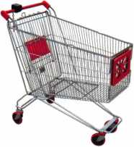

\

You need it When?

**How about now!? :-)**

ClearStar

Another Special  
Value-added Benefit to your

ALO A Membership! Click here .

|  |  |  |
| --- | --- | --- |
|  | [www.clearstar.com/ALOA](http://www.clearstar.com/ALOA) |  |
|  |  | ) |

IN-STOCK...MORE SAFES

***FREE Freight Program***

***(30 States)***

AMSEC FireKing

Gardall **hayman**

**MEIUNK** Y/CTO/Z

**TURfl lO**

**WHOLESALE SERVICE**

800-848-9790

003634

REPAIR

TAG

ooiiooaoantiCiQf

^DODOilli*’ irQUDDOQDn

COM^Ny

Nyrnhar

KEY & LOCKSk * 4525 HamptonAvK Phone (314) 752-3311

VOUR FIRM NAME ,

123 Main Street YOUR TOWN, STATE At

Phone 123-4567

0004115

*?Wo/CE

**Professional Business Products**

Invoices Tags *Call for a free*

Checks Key Fobs *brochure and samples*

**Business Magnets 1-800-355-6322**

Cards Labels [www.pbp2000.com](http://www.pbp2000.com)

ACCEPT CREDIT CARDS!

**No application fees**

**No Monthly Minimum**

**No Lease Requirements**

**Onsite wireless terminals available**

In your Locksmithing Business, Storefronts/Offices/Homebased

RETRIEVER PAYMENT SYSTEMS

888-549-6424

Keynotes • April 2QOB

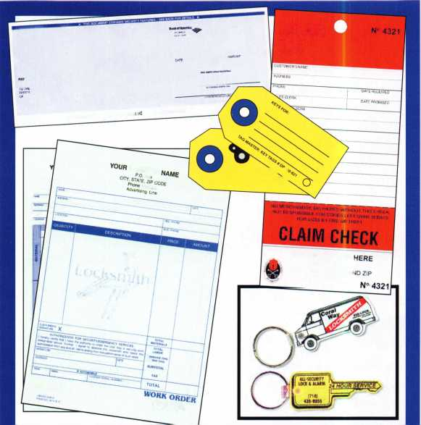

*OPERATOR SAFETY*

Injuries can be virtually eliminated. Ultra Lift does the lift-  
ing so that operator effort required to complete a move is  
minimized. Heavy loads are broken back with ease. The  
operator stays in control by using a combination of motor  
power, balance and leverage in every phase of a move.

*REDUCE LABOR COSTS*

Fewer people are required for any move with Ultra Lift.  
Manpower can be scheduled more productively. Labor  
savings often pay for the Ultra Lift in one month.

*ELIMINATE DAMAGE*

Loads are broken back, set down and moved under power  
with maximum leverage and operator control. Gentle  
handling eliminates bumps, bounces and damage to the  
load and premises.

*INCREASE PROFITS*

Increased operator safety, reduced labor cost and elimina-  
tion of damage to the load and premises all contribute to  
significant increases in profits.

FOR LITERATURE, VIDEO OR ON-SITE  
DEMONSTRATION, WRITE OR CALL:

ULTRA LIFT CORPORATION

475 STOCKTON AVENUE, UNIT E  
SAN JOSE, CA 95126  
800-346-3057  
408-287-9400  
FAX 408-297-1199  
E-mail: [info@uItraIift.com](mailto:info@uItraIift.com)  
[www.ultralift.com](http://www.ultralift.com)

US. **PATENT 4.570.953**

ULTRA LIFT supplies the power - so you don't have  
to. One person can safely and easily handle loads  
that usually require 2 or 3 people, even up or down  
stairs. Two people can handle most safes to 1500  
pounds. If safety is your concern, ULTRA LIFT is the  
best move you'll ever make!

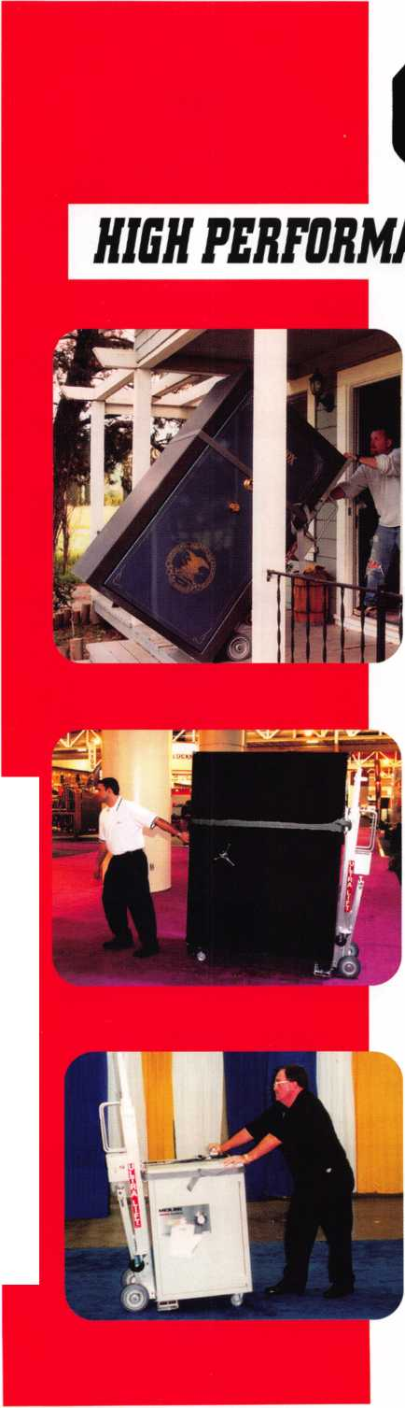

This year we’re back in LEXINGTON for the 150th Anniversary of Sargent & Greenleaf.

**Keeping up with the latest the industry has to offer has never been this important - or this FUN! When it comes to learning about the latest**

*o*

**in safes and vaults, time is of the essence. SAFETECH 2007 fea­tures an all-new menu of classes, covering every safe topic on the globe.**

**SAFETECH**

**LEXINGTON’S**

**READY.**

**ARE YOU?**

***OUR SAFETECH 2007 SPONSORS!!***



***THE RACE STARTS HERE***



**MARCH 5th thru**

**MARCH**

**LEXINGTON**

**KENTUCKY**

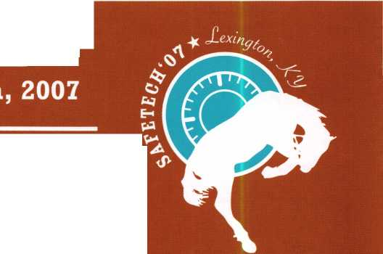

Alberto, 11 years Machine Operator

SECURITY PRODUCTS

Raymond, 4 years Accounting

Shirley, 23 years Lock Assembly

(, 8 years omer Service

We represent the 500 employees of CompX Security Products.

Hardworking. Reliable. Dedicated.

And it shows in the products we make.

Is it any surprise that, year after year, you the locksmith community, choose to partner with us?

Made in America does matter to you, and it matters to us. Through our four US facilities, we will continue to provide you with the high quality products you have come to expect from CompX Security Products.

TIMBERLINE

FORT

NATIONAL

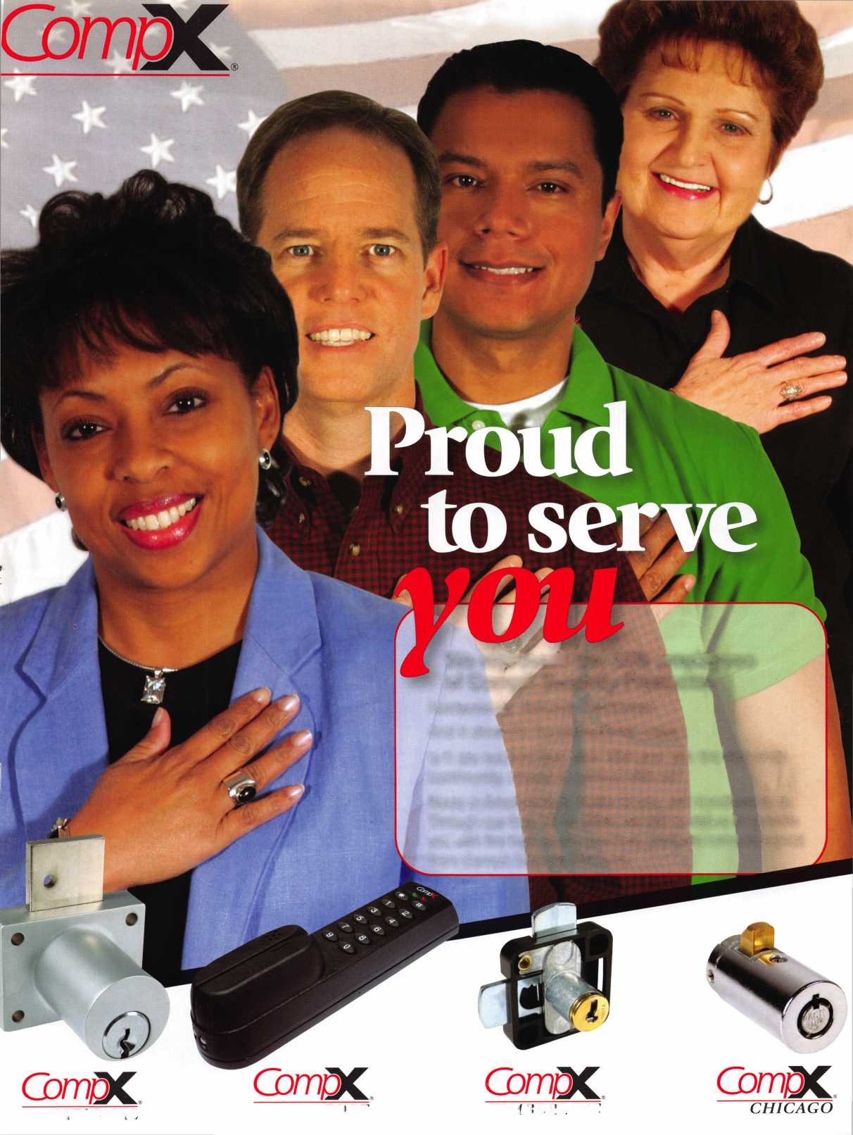

j

I

I

l

i

i

**Adesco Fi reking/Gary MEILINK**

OR SAFES THAT FIT EVERY NEED AND BUDGET, COUNT ON THE TRUSTED

ids **of FireKing® Security Group. Adesco® offers safes**

GOVERNMENT, COMMERCIAL AND RESIDENTIAL CUSTOMERS. MEILINK® IDES FIRE- AND B U RG LARY-R ATE D SAFES FOR BANKS, SCHOOLS RETAIL ESTABLISHMENTS. AND FlREKlNG FEATURES UL®-RATED FIRE/

at

**FireKing**

**rfhi irity** nnm

SECURITY GROUP

[www.fireking.com](http://www.fireking.com)

